HIGHER LOCAL GOVERNMENT STATISTICAL ABSTRACT

MBARARA DISTRICT

2013

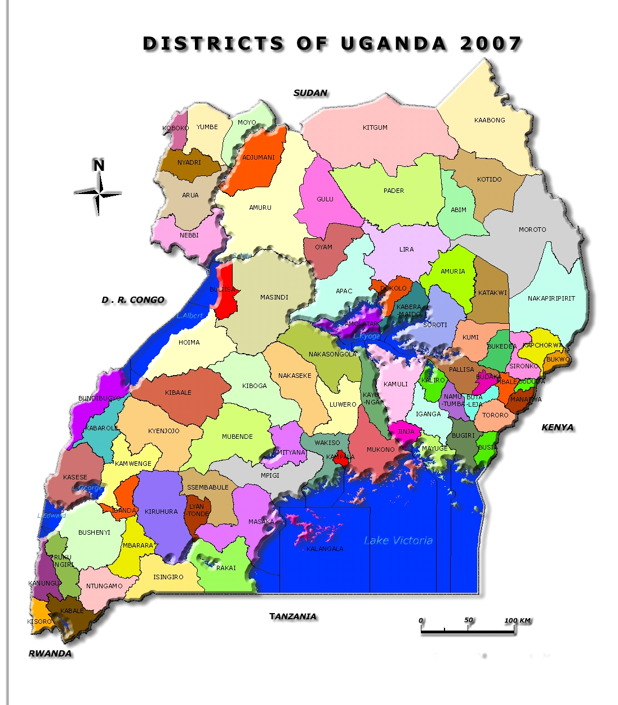
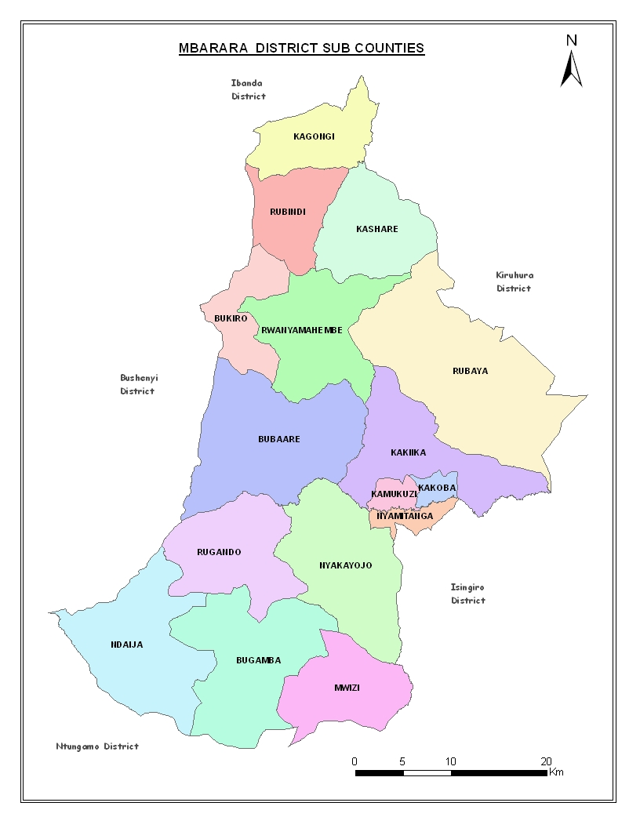

P.O Box 1, Mbarara-Uganda
Tel: 20002/20009214233
Email: caombrarara@gmail.com
August 2013

TABLE OF CONTENTS

LIST OF ACRONYMS......................................................................................................................4
FORWARD.....................................................................................................................................7
ACKNOWLEDGEMENTS................................................................................................................8
EXCUTIVE SUMMARY...................................................................................................................9
BACKGROUND INFORMATION...................................................................................................10
A. THE LOCATION............................................................................................................10
B. SIZE AND TOPOGRAPHY.............................................................................................10
C. HISTORICAL BACKGROUND........................................................................................10
D. POPULATION SIZE.......................................................................................................10
CHAPTER 1: MANAGEMENT SUPPORT SERVICES......................................................................11
1.1 GENERAL ADMINISTRATION....................................................................................11
1.1.1 Number of administrative units:...........................................................................11
1.2.2 RECORDS...............................................................................................................12
1.2.4 COUNCIL, BOARDS AND COMMISSIONS...............................................................13
1.2.5 PUBLIC ACCOUNTS COMMITTEE (PAC).................................................................13
1.2.6 CONTRACTS COMMITTEE.....................................................................................13
1.2.7 LAND BOARD........................................................................................................14
CHAPTER 2: FINANCE AND PLANNING......................................................................................15
2.1 MBARARA SIZE AND GROWTH................................................................................15
2.2 SEX COMPOSITION..................................................................................................16
2.2.7 Population Density...............................................................................................20
2.2.8 Urbanization........................................................................................................20
2.2.9 Migration............................................................................................................21
2.2.11 Education and Literacy.....................................................................................21
2.2 SECTION TWO: SOCIO-ECONOMIC CHARACTERISTICS.....................................................23
2.2.2 Household Amenities..........................................................................................24
2.2.3 Special Interest Population Groups....................................................................26
2.2.4 Distribution Persons with Disabilities................................................................26
2.2.6 Information, Communication and Transportation.............................................30
CHAPTER THREE:HEALTH SERVICES........................................................................................32
3.1 Introduction: HEALTH SERVICES IN GENERAL:......................................................32
3.2 Health infrastructure by location and ownership 2012/2013..............................32
3.4 Public Health / Environmental Health..................................................................35
3:4:3 Health Promotion and Education......................................................................36
3:4.4 Drugs, Drugs Inspection and Drug Shops..........................................................36
3:4.5 Vector Control Activities...................................................................................36
3:4:6 T.B / Leprosy Control:.......................................................................................36
CHAPTER 4: EDUCATION AND SPORTS..................................................................................42
4:1:0 EDUCATION IN GENERAL..................................................................................42
Table: 4.2: Primary School enrollment by school per class and corresponding classrooms.................................................................................................................42
Source: UNEB PLE RESULTS 2013..............................................................................42
Table 4.4: Key indicators for schools.........................................................................43

CHAPTER 5: WORKS AND TECHNICAL SERVICES.........................................................................44
5:1:0 WATER...................................................................................................................44
7.0 GENERAL COMMUNITY ISSUES.................................................................................51
7.1 GENDER AND CULTURE............................................................................................51
7.2 ELDERLY AND DISABILITY..........................................................................................51
CHAPTER 8: PRODUCTION AND MARKETING.............................................................................52
8.1 Agriculture................................................................................................................52
8:1:1 Crops.....................................................................................................................52
8.2 Livestock and Veterinary Services............................................................................53
8.3 Fisheries....................................................................................................................53
8.3.2 Major diseases and predators...............................................................................53
8.5 Extension Services....................................................................................................55
8.6 Trade........................................................................................................................55
List of SACCOS by membership, shares and working capital........................................56

LIST OF TABLES

Table 1.1 Number of administrative units 2012/2013.......................................................... 12
Table 1.3: Staffing levels by sector and sex.......................................................................... 13
Table 1.5: Showing Staffing Levels of Statutory boards........................................................ 14
Table 1.6: Showing Performance of PAC.............................................................................. 14
Table 1.7: Showing performance of contract Committee (FY 2012/2013)........................... 14
Table 1.8: Showing performance of Land Board for FY 2012/2013...................................... 15
Table 1.8: Council Performance for...................................................................................... 15
Table 2.1: Population distribution by County....................................................................... 17
Table 2.3: Age groups by sex................................................................................................ 18
Table 2.4: Mbarara District population projections from 1980-2013.................................. 20
Table 2.5: Population density per sub-county...................................................................... 22
Table 2.6: Toilet facilities by Urban and Rural Mbarara....................................................... 23
Table 2.7: School Attendance by Age and Sex for the Population Aged 6 Years and above 24
Table 2.8: Type of dwelling Units...............................................................................................25
Table 2.9: Type of Housing Units................................................................................................25
Table 2.10: Construction Materials............................................................................................25
Table 2.11: Source of cooking fuel.............................................................................................26
Table 2.12: Source of Lighting Fuel............................................................................................26
Table 2.13: Bathroom.................................................................................................................27
Table 2.14: Kitchen distribution by type....................................................................................27
Table 2.15: Solid Waste Disposal by type...................................................................................27
Table 2.16: Household Assets....................................................................................................28
Table 2.17: Activity Status for the Youth....................................................................................28
Table 2.18: The young people (youth) distribution by sex and age group.................................28
Table 2.21: Literacy by sex for the disabled...............................................................................30
Table 2. 22: Educational attainment by sex for the disabled....................................................30
Table 2.22: Orphan hood Status for Children (Less than 18 Years Old) by Sub-county ............32
Table 2.23: Household Transportation.......................................................................................33
Table 2.24: Household Information Percentage........................................................................33
Table 3.2: Health staff in the District 2012/2013.......................................................................35
Table 3.3: Distribution of Health Centre 2012/2013.................................................................35
Table 3.2: Disease Burden.........................................................................................................36
Table 3.3: Accessibility of health services.................................................................................36
Table 3.4: Immunizations:.........................................................................................................39
Table 3.5: Source of Drinking water..........................................................................................39
Table 3.6: Safe water coverage is 62.2%...................................................................................41
Table 3.7: Latrine coverage.......................................................................................................41
Table 3.8: Public Health/ Environmental Health Education.......................................................42
Table 3.9: Tuberculosis, and Onchocerciasis..............................................................................42
Table 3.10: Maternal and Child health (MCH)............................................................................42
Table: 4.2: Primary School enrollment by school per class and corresponding classrooms......44
Table: 4.3: PLE results 2013........................................................................................................44
Table 4.4: Key indicators for schools..........................................................................................45
Table 5.2.3 SCOPE OF FEEDER ROAD NETWORK........................................................................47
Table 7.1: Functional Adult literacy programme........................................................................53
Table 8.1: Common crops grown in Mbarara.............................................................................54
Table 8.2: Number of livestock per sub county by type.............................................................55
Table 8.5: Number of Beneficiaries by Project type and Sex.....................................................56

LIST OF FIGURES

Figure 2.2: Population growth rate by sex, by county................................................................18
Figure 2.3: Sex by age group......................................................................................................19
Figure 2.4 Population by age by sub-county..............................................................................21
Figure 2.8: Population composition by age and sex...................................................................29
Figure 2.9:Economic activities by status for the disabled..........................................................30
Figure 2.10:Literacy by sex for the disabled..............................................................................30
Figure 2.11 Educational attainments by sex for the disabled.....................................................31
Figure 2.12:Marital status by sex for the disabled......................................................................31

LIST OF ACRONYMS

CAO Chief Administrative Officer
CC Contracts Committee
DAO District Agricultural Officer
DEO District Education Office
DLB District Land Board
DHO District Health Office
DSC District service commission
DVO District Veterinary Officer
DFO District Forestry Officer
LC V Local Council Five Chairperson
NAADS National Agricultural Advisory Services
PAC Public Accounts Committee
PO Personnel Officer
POPSEC Population Secretariat
SPO Senior Personnel Officer
STPC Sub-County Technical Planning Committee
UBOS Uganda Bureau of Statistics

FORWARD

The district abstract is a comprehensive summary of statistics on the social, political and economic organisation of the district. It provides in a single convenient reference, the most useful available current data, for the District.

The user is urged to read carefully the notes at the beginning of each chapter and any footnotes accompanying the tables.

Much of the value of the abstract lies in its many references to other sources of information. Every effort has been made to provide abstract users with the most complete data collection possible.

Special thanks go to District planning unit staff for their tireless efforts towards the preparation of this Abstract.

I appeal to everyone to appreciate and use the abstract as a convenient volume for statistical reference and as a guide to sources of more information. It is my hope that the document will be of great importance to data users.

.......................................
Tumusiime Deus
CHAIRPERSON MBARARADISTRICT LOCAL GOVERNMENT

ACKNOWLEDGEMENTS

Mbarara District Local Government is mandated to producing a district abstract. This is updated every calendar year catering for new development and changes in statistical indicators.

I am grateful to the District Planning Unit for their unique role in coordinating the completion of the document.
The entire completion met a number of challenges highlighted below:
- Inability to obtain adequate data on some indicators
- Failure to obtain the required data timely

There is a need in future to put the necessary strategies in place to ensure timely production and utilization of the abstract such as induction of district stakeholders on the role of data in planning, budgeting and monitoring.

I appeal to all stake holders to appreciate and use the document for the development of the district

LUBUUKA DAVID
CHIEF ADMINISTRATIVE OFFICER/ MBARARA DISTRICT

EXCUTIVE SUMMARY

Mbarara District is consisted of sub counties 14, 3 divisions, 83 parishes and 757 villages. The district is well staffed at around 80 percent. Council, PAC and Land boards are fully filled. 89.6 percent of the district land is under subsistence agriculture, 16 percent under commercial agriculture and 5.4 under forest reserves.

The population projection for Mbarara district stands at 445,600 by 2012 compared to 2002 which was 361,477. The growth rate is averaged at 2.8 percent which is lower than the national one of 3.2.

Mbarara district hosts 4 hospitals, 4 HC IV, 13 HC III and 29 HC II. The immunization coverage was at 85percent; safe water coverage at 62 by 2010, latrine coverage at 92.4 percent but malaria has remained a common disease with the 62 percent of the total disease burden.

Primary school enrolment has maintained a positive trend of around 5.4 percent and currently it standards at 489,784. Drop outs have also remained high almost half of the pupils who enrol for P1 complete P7.

BACKGROUND INFORMATION

A. THE LOCATION
Mbarara District is located in the South Western part of Uganda. It boarders with the following areas:
- Ibanda and Kiruhura Districts to the North
- Kiruhura and Isingiro Districts to the East
- Isingiro and Ntungamo Districts to the South
- Bushenyi District to the West.

B. SIZE AND TOPOGRAPHY
It covers an area of 1846.4 sq. km. The District has a mixture of fairly rolling and sharp hills, fairly deep and shallow valleys and flat land. The soils are loamy fertile literate soils, suitable for cultivation

C. HISTORICAL BACKGROUND.
The current Mbarara District Local Government, came into being as a result of the people’s wishes and authority of Parliament in 2005 to reduce Mbarara District to two counties and one municipality namely Kashari county, Rwampara county and Mbarara Municipality. Bukanga and Isingiro counties formed Isingiro District, Nyabushozi and Kazo counties formed Kiruhura District While Ibanda County formed Ibanda District.

Mbarara District is located in the South Western part of Uganda. It boarders with the following areas:
- Ibanda and Kiruhura Districts to the North
- Kiruhura and Isingiro Districts to the East
- Isingiro and Ntungamo Districts to the South
- Bushenyi District to the West.

D. POPULATION SIZE
Population Characteristics/Profile as 2013
- Percentage District Population of National Population:….... 1.5%
- Urbanization rate ………………………………………….. 19%
- Average Household Population …………………………… 5
- Under 18 years ……………………………………………. 55%
- 60 years and above ………………………………………... 5%
- Total Fertility rate ……………………………………….... 7.0%
- Population size ………………………………………………489784

CHAPTER 1: MANAGEMENT SUPPORT SERVICES

1.1 GENERAL ADMINISTRATION

1.1.1 Number of administrative units:

The District has two counties, one Municipal Council, Fourteen sub counties, Eighty three parishes, six wards and seven hundred fifty seven villages as represented below:

Table 1.1 Number of administrative units 2012/2013
Subcounty | Number of Parishes | Number of villages
Kashari
Biharwe | 5 | 32
Bubaare | 6 | 34
Bukiro | 4 | 33
Kagongi | 6 | 62
Kakiika | 5 | 26
Kashare | 4 | 65
Rubaya | 5 | 41
Rubindi | 6 | 62
Rwanyamahembe | 5 | 43
Mbarara Municipality
Kakoba | 2 | 21
Kamukuzi | 2 | 14
Nyamitanga | 2 | 16
Rwampara
Bugamba | 7 | 70
Mwizi | 5 | 55
Ndaija | 7 | 57
Nyakayojo | 6 | 61
Rugando | 5 | 53
Total | 83 | 757

1.2 HUMAN RESOURCE MANAGEMENT
Staffing level in the district by departments
1.2.1 PERSONNEL IN THE DISTRICT

Mbarara district is well staffed on average but with a problem of high labour turnover in some key departments.

Table 1.3: Staffing levels by sector and sex
SECTOR | MALE | FEMALE | TOTAL
Administration | 81 | 26 | 107
Council | 3 | 2 | 5
Education | 5 | 4 | 9
Community | 21 | 13 | 34
Finance & planning | 21 | 12 | 33
Production | 21 | 7 | 28
Health | 117 | 162 | 279
Works | 17 | 2 | 19
Natural resources | 8 | 5 | 13
TOTAL | 294 | 233 | 527
Source: District Personnel Reports

1.2.2 RECORDS
The district keeps a number of records in different registries. These include the main Registry, Education Registry, Health registry, Lands Registry among others

    - AUDIT

Table 1.4: Showing number of audits in FY 2012/2013
Item | Local government units | Departments | Institutions | Special investigations
No. | 14 | 11 | 48 | 04

Special audits were carried out at Nombe SSS, Roads and works department and NAADS in Kagongi and Rubindi subcounties

1.2.4 COUNCIL, BOARDS AND COMMISSIONS

Table 1.5: Showing Staffing Levels of Statutory boards (FY 2012/2013)
COUNCIL STRUCTURE | STATUTORY | NUMBER | VACANT
 | NUMBER | FILLED | POSITIONS
Full council | 33 | 33
Executive committee members | 5 | 5 | 0
Speakers | 2 | 2 | 0
PWD Representatives | 2 | 2 | 0
Youth Representatives | 2 | 2 | 0
Women Representatives | 2 | 2 | 0
Elders Representatives | NIL | NIL | 0
Sect oral committees:
Finance Committee | 5 | 5 | 0
Works committee | 6 | 6 | 0
Social services committee | 5 | 5 | 0
Public Accounts Committee | 5 | 5 | 0
Contracts Committee  Production and Marketing  Community Based Committee  Service Commission Committee | 5  5  5  5 | 5  5  5  4 | 0  0  0  1

1.2.5 PUBLIC ACCOUNTS COMMITTEE (PAC)

Table 1.6: Showing Performance of PAC (FY2012/2013)
Item | PAC Membership | PAC Reports Made | PAC Meetings
Number | 5 | 1 | 4
Source: Clerk to Council Reports

1.2.6 CONTRACTS COMMITTEE

Table 1.7: Showing performance of contract Committee (FY 2012/2013)
Item | Membership | Meetings | Reports | Bids | Firms | Contracts
 |  | held | made | Received | Pre-qualified | awarded
Number | 5 | 11 | 4 | 89 | 79 | 48
Source: Contract committee Reports

1.2.7 LAND BOARD

Table 1.8: Showing performance of Land Board for FY 2012/2013
Item | Membership | Meetings  Held | Submissions From Land Committees | Disputes Handled/  Resolved
No. | 5 | 2 | 557 | 40
Source: Land Board Reports

1.2.7 SUMMARY OF COUNCIL PERFORMANCE

Table 1.8: Council Performance for FY2012/2013
Item | Meetings  Held | No. of by laws passed | No. Of Executive meeting
No. | 6 | 0 | 12
Source: Land Board Report

CHAPTER 2: FINANCE AND PLANNING

2.1 MBARARA SIZE AND GROWTH

Mbarara District had a total population of three hundred sixty one thousand, four hundred seventy seven in 2002. It contributed one point seven percent of the country’s total population of twenty four point two million people. The District average population growth rate is 2.8 percent which is lower than the country’s growth rate of 3.2 percent.

Table 2.1: Population distribution by County

COUNTY | 1991 POPULATION |  | 2002 POPULATION |  | 2013 POPULATION |  | Total | Growth Rate
 | Male | Female | Male | Female | Male | Female |  | Male | Female
Kashari | 59461 | 62623 | 78329 | 81823 | 106132 | 110866 | 216998 | 3.22 | 3.12
Rwampara | 58402 | 61917 | 64416 | 67546 | 87281 | 91522 | 178803 | 1.14 | 1.02
Mbarara  Municipality | 21493 | 19538 | 34214 | 35149 | 46358 | 47625 | 93983 | 5.42 | 6.85
Mbarara Total | 139356 | 144078 | 176959 | 184518 | 239771 | 250013 | 489784 | 2.79 | 2.89
Source: UBOS, Population projections 2013

Figure 2.1: Population distribution by county

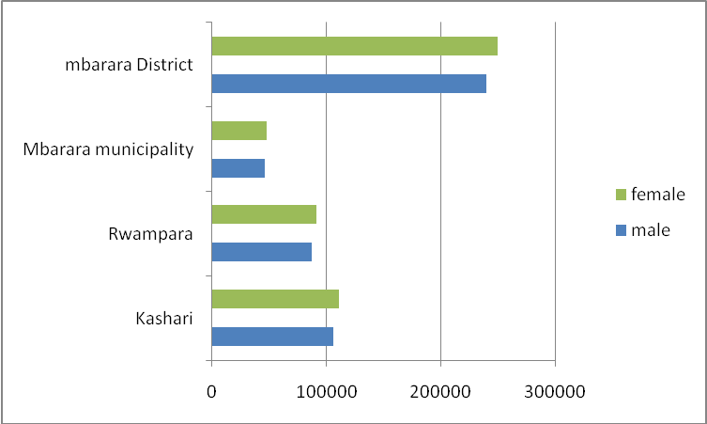

All the counties in Mbarara district have the highest number of females compared to males. Therefore there is need for effective planning for majority females since most of them are employed in agriculture sector

Figure 2.2: Population growth rate by sex, by county
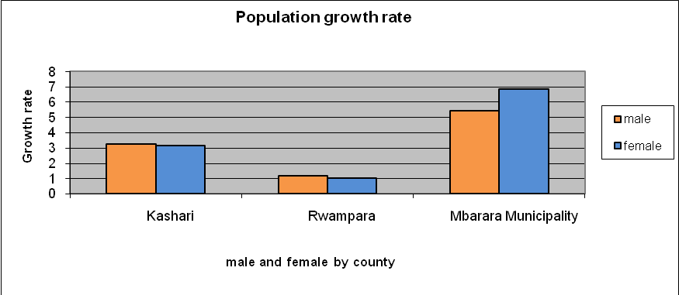
Source: UBOS, SUB National Population projections 2013

Figure 2.2 shows that the growth rate for males and females is fairly stable in Kashaari and Rwampara. In The Municipality, the rate is higher for females. In conclusion we note that the average population growth rate for Mbarara district is 2.84 percent.

2.2 SEX COMPOSITION.
The male to female sex ratio in Mbarara is 1:1.05 (Source: 2002 Census)

Table 2.3: Age groups by sex
Age Groups by Sex | Male | Female | Total
0-4 | 30,471 | 30,553 | 61,024
5-9 | 26,434 | 27,032 | 53,466
10-14 | 25,079 | 26,393 | 51,472
15-19 | 21,045 | 22,423 | 43,468
20-24 | 17,389 | 19,324 | 36,713
25-29 | 14,128 | 14,871 | 28,999
30-34 | 12,014 | 10,934 | 22,948
35-39 | 8,246 | 7,829 | 16,075
40-44 | 6,250 | 6,289 | 12,539
45-49 | 3,797 | 4,036 | 7,833
50-54 | 3,063 | 3,633 | 6,696
55-59 | 2,081 | 2,618 | 4,699
60-64 | 2,003 | 2,685 | 4,688
65-69 | 1,476 | 1,710 | 3,186
70-74 | 1,279 | 1,650 | 2,929
75-79 | 664 | 770 | 1,434
80-84 | 733 | 982 | 1,715
85-89 | 241 | 289 | 530
90-95 | 371 | 430 | 801
Total | 176,764 | 184,451 | 361,215
Source: Source: 2002 Census

Figure 2.3: Sex by age group
Source: 2002 Census

Figure 2.3 indicates that the majority of Mbarara district population lies between 0-19 years, these are dependants. The districts need to plan for their basics needs.

Chart 2.1: Population Distribution by Sex

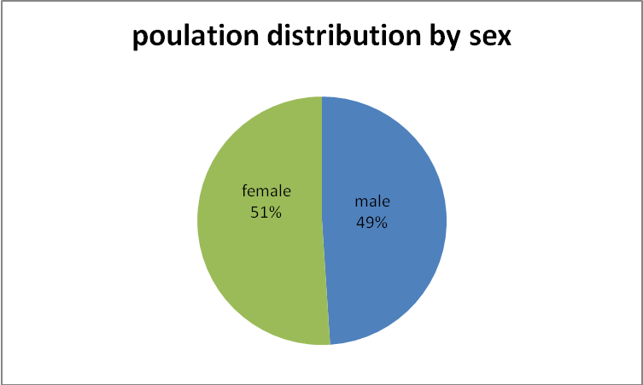

Source: UBOS Population Projection 2013

2.2.4 Population Projection

Population Census is carried out after a period of 10 years. During this time, population changes taken place due to, Fertility, Mortality and Migrations. Therefore there is need to project population for planning purposes. Population projections a very accurate when forecasts are done after a shorter time and the projection error increases with time.

Table 2.4: Mbarara District population projections from 1980-2013
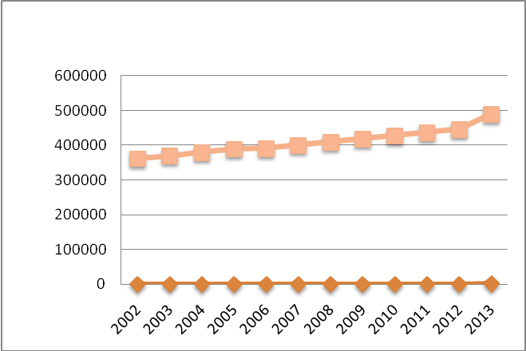

 |  |  |  |  |  |  | 2002 | 361,477
 |  |  |  |  |  |  | 2003 | 369,300
 |  |  |  |  |  |  | 2004 | 379,300
 |  |  |  |  |  |  | 2005 | 389,700
 |  |  |  |  |  |  | 2006 | 390,400
 |  |  |  |  |  |  | 2007 | 400,300
 |  |  |  |  |  |  | 2008 | 409,100
 |  |  |  |  |  |  | 2009 | 418,300
 |  |  |  |  |  |  | 2010 | 427200
 |  |  |  |  |  |  | 2011 | 436400
 |  |  |  |  |  |  | 2012 | 445600
 |  |  |  |  |  |  | 2013 | 489784

Source: UBOS Population Projection 2013

The population growth rate for Mbarara district has averaged on 2.8 percent compared to the national growth rate of 3.2. But rate is high compared to the available resource accumulation; this has led to land fragmentation and hence limiting commercial agriculture in most of the areas. From 2008 to 2002 the figure includes the greater Mbarara.

Table 2.4: Population by age
 | Children |  |  |  |  | Adolescents |  |  | Adults
County |  |  |  |  |  |  |  | All Adults |  | Youths |  | Elderly (60
Sub county | Under 1 | Under 5 | Under12 | Under 15 | Under 18 | 14-Above | 15-24 | (18 above) | (18-30) |  | (and above)
Kashari | 6556 | 28058 | 34099 | 75917 | 87306 | 23154 | 33097 | 72846 | 36770 |  | 7310
Bubaare | 725 | 3118 | 3875 | 8583 | 9962 | 2698 | 3799 | 8452 | 4114 |  | 813
Bukiro | 523 | 2348 | 2872 | 6385 | 7320 | 1983 | 2498 | 5602 | 2664 |  | 595
Kagongi | 809 | 3571 | 4455 | 9763 | 11110 | 2927 | 3623 | 8419 | 3973 |  | 1010
Kakiika | 655 | 2461 | 2552 | 6083 | 6974 | 1722 | 3657 | 8122 | 4778 |  | 544
Kashare | 835 | 3506 | 4368 | 9616 | 11121 | 2979 | 4136 | 8860 | 4343 |  | 1012
Rubaya | 1275 | 5655 | 6721 | 15064 | 17315 | 4508 | 6538 | 14359 | 7318 |  | 1397
Rubindi | 909 | 3695 | 4621 | 10128 | 11621 | 3081 | 4233 | 9214 | 4543 |  | 970
Rwanyamahembe | 825 | 3704 | 4635 | 10295 | 11883 | 3256 | 4613 | 9818 | 5037 |  | 969
Mbarara Municipality | 2599 | 10018 | 11103 | 25934 | 31056 | 8121 | 19957 | 38307 | 24644 |  | 1408
Kakoba | 1423 | 5214 | 5327 | 12749 | 15130 | 3689 | 10038 | 19141 | 12867 |  | 520
Kamukuzi | 800 | 3094 | 3683 | 8411 | 10283 | 2770 | 6949 | 13187 | 8347 |  | 467
Nyamitanga | 376 | 1710 | 2093 | 4774 | 5643 | 1662 | 2970 | 5979 | 3430 |  | 421
Rwampara | 5546 | 22950 | 29384 | 64118 | 73965 | 20200 | 27190 | 57997 | 28507 |  | 6568
Bugamba | 1267 | 5115 | 6513 | 14207 | 16353 | 4365 | 5909 | 12469 | 6101 |  | 1397
Mwizi | 1358 | 5293 | 6049 | 13677 | 15483 | 4021 | 5096 | 10653 | 5389 |  | 950
Ndaija | 1050 | 4072 | 5471 | 11799 | 13737 | 3831 | 5167 | 11069 | 5308 |  | 1296
Nyakayojo | 1061 | 4793 | 6409 | 13771 | 15897 | 4527 | 6248 | 13499 | 6864 |  | 1558
Rugando | 810 | 3677 | 4942 | 10664 | 12495 | 3456 | 4770 | 10307 | 4845 |  | 1367
GRAND TOTAL | 29402 | 122052 | 149172 | 331938 | 384654 | 102950 | 160488 | 338300 | 179842 |  | 30572
Source: Source: 2002 Census

Figure 2.4 Population by age by sub-county

2.2.7 Population Density

This refers to the number of persons per square kilometer. The higher the population density the higher the population pressure on land. Kakoba division has the highest population density in the urban center while Mwizi sub-county has the highest in rural Mbarara. Nyamitanga division has the lowest population density in urban and Bubaare for rural Mbarara.

Table 2.5: Population density per sub-county
County | Sub-county | Population density 2013
Kashari (Rural) | Bubaare | 96.9
Kashari (Rural) | Bukiro | 243.8
Kashari (Rural) | Kagongi | 230.3
Kashari (Rural) | Kakiika | 115.5
Kashari (Rural) | Kashare | 209.0
Kashari (Rural) | Rubaya | 215.5
Kashari (Rural) | Rubindi | 141.8
Kashari (Rural) | Rwanyamahembe | 163.9
Rwampara(Rural) | Bugamba | 166.3
Rwampara(Rural) | Mwizi | 308.2
Rwampara(Rural) | Ndeija | 174.9
Rwampara(Rural) | Nyakayojo | 211.2
Rwampara(Rural) | Rugando | 188.9
Mbarara municipality (Urban) | Kakoba | 2,596.3
Mbarara municipality (Urban) | Kamukuzi | 1,397.0
Mbarara municipality (Urban) | Nyamitanga | 564.2
 | District population density | 213.8
 | Average household size | 4.7
Source: UBOS Population projections

2.2.8 Urbanization

Urbanization can be defined as the increase in the proportion of the population living in urban areas. However, the definition of urbanization has been changing with time. The 2002 Census defined urban areas as only the gazetted ones while the earlier Census included un-gazetted Trading Centres with more than 1,000 people as part of the Urban Population. Today the district has one town Council, Mbarara town council and four town boards. However, the district has an advantage of being on the Highway i.e. Kabale-Kampala. For this reason, the district has many mushrooming trading Centres along the Highway. These are Buteraniro, Nyeihanga,Kinoni, Rugando and Ruti Trading Centres for Rwampara county and Rubindi, Rutooma,Bwizibwera and Biharwe trading centres for Kashaari county.

Table 2.6: Toilet facilities by Urban and Rural Mbarara

Toilet Facilities by Urban And Rural
 | Urban | Percentage | Rural | Percentage | Total
Covered pit latrine/private | 2,403 | 7 | 31,898 | 93 | 34,301
Covered pit latrine/shared | 10,601 | 37 | 18,430 | 63 | 29,031
VIP latrine/private | 517 | 34 | 1,025 | 66 | 1,542
VIP latrine/shared | 1,790 | 67 | 865 | 33 | 2,655
Uncovered pit latrine | 598 | 13 | 4,103 | 87 | 4,701
Flush toilet/Private | 952 | 83 | 196 | 17 | 1,148
Flush toilet/shared | 823 | 78 | 237 | 22 | 1,060
Bush | 43 | 3 | 1503 | 97 | 1,546
others specify | 22 | 18 | 100 | 82 | 122
Source: 2002 Census

2.2.9 Migration

This refers to the movement of persons from their usual place of environment to another place to stay there temporarily or permanently. There are two broad categories of movement’s namely internal migration and international migration. International migration in this case refers to the movement of persons across national boundaries, while internal migration refers to the movement of persons within the same nation. At the time of the census, Mbarara District had 84% of its population having been born and stayed in the District. The remaining 16% comprised of visitors to the District and immigrants. Visitors accounted for 1.7%. Of the 14.3% Immigrants, 5.4% were from Bushenyi, 1.7% from kabala, 1.6% from Ntungamo, 1% from Rukungiri. The remaining 4.6% came from various places.

2.2.11 Education and Literacy

Uganda’s education system includes formal and informal education comprises of training at primary, secondary, and tertiary levels. It is a 7,4,2,3 system i.e. primary 7 years, secondary 4 years for Uganda certificate of education (“O level) and 2 years for advanced certificate of education (A” level) and tertiary education from 3 to 5 years. Informal education trains beneficiaries in basic skills of education like reading writing and numeric.

Tertiary education includes Universities, colleges of commerce, technical and vocational colleges, technical institutes and teacher training colleges. Admission to tertiary institution requires at least a Ugandan certificate of education (UCE).2.2.12 School attendance Status.
Table 2.7: Mbarara District P.L.E Results 2000/2013
YEAR |  | DIV. I |  |  | DIV. II |  |  | DIV.III |  |  | DIV.IV |  |  | DIV.V |  |  | ABSENT |  |  | TOTAL
 | No. |  | %age | No. |  | %age | No. |  | %age | No |  | %age | No. |  | %age | No. |  | %age
2000 | 1975 |  | 15.15 | 5810 |  | 44.3 | 1971 |  | 15 | 1814 |  | 13.8 | 1225 |  | 9.3 | 310 |  | 2.4 | 13105
2001 | 1401 |  | 11.2 | 5208 |  | 41.5 | 2086 |  | 16.6 | 1626 |  | 13 | 1615 |  | 13 | 611 |  | 4.9 | 12547
2002 | 457 |  | 2.5 | 4001 |  | 22.1 | 3702 |  | 20.5 | 2486 |  | 13.8 | 5842 |  | 32 | 1585 |  | 8.8 | 18073
2003 | 720 |  | 4.1 | 4867 |  | 27.4 | 3827 |  | 21.5 | 2386 |  | 13.4 | 4180 |  | 24 | 1783 |  | 10 | 17763
2004 | 659 |  | 3.9 | 5744 |  | 3.6 | 3305 |  | 19.4 | 2860 |  | 16.7 | 3115 |  | 18 | 1395 |  | 8.2 | 17078
2005 | 162 |  | 3 | 2215 |  | 41 | 1455 |  | 27 | 542 |  | 10.1 | 573 |  | 11 | 437 |  | 8.1 | 5384
2006 | 408 |  | 8.8 | 2657 |  | 77.4 | 935 |  | 20.2 | 366 |  | 7.8 | 272 |  | 5.8 | 329 |  | 7 | 4967
2007 | 465 |  | 9.4 | 2704 |  | 20.3 | 1002 |  | 20.3 | 346 |  | 17 | 410 |  | 8.3 | 514 |  | 9.4 | 5441
2008 | 245 |  | 4.7 | 2669 |  | 50.8 | 1517 |  | 28.9 | 428 |  | 8.2 | 390 |  | 7.4 | 209 |  | 3.8 | 5458
2009 | 528 |  | 9.2 | 3382 |  | 58.7 | 1249 |  | 21.7 | 325 |  | 5.7 | 273 |  | 4.7 | 209 |  | 3.8 | 5921
2010 | 814 |  | 14.2 | 3455 |  | 60.2 | 445 |  | 7.7 | 255 |  | 4.4 | 191 |  | 3.3 | 180 |  | 3.1 | 5740
2011  2013 | 861  1180 |  | 14.1  18.2 | 3529  3792 |  | 57.6  58.5 | 877  755 |  | 14.31  11.7 | 416  337 |  | 6.787  5.2 | 275  242 |  | 4.5  3.7 | 168  174 |  | 2.74  2.7 | 6129  6480
Source: Education Department 2013

Table 2.7: School Attendance by Age and Sex for the Population Aged 6 Years and above
Age  Group | Attended School |  |  | Left School |  |  | Never Attended School |  |  | Total
 | M | F | T | M | F | T | M | F | T | M | F | T
6 -9 | 18,061 | 18,663 | 36,724 | 175 | 180 | 355 | 2444 | 2288 | 4732 | 20,680 | 21,131 | 41,811
10-12 | 14,408 | 15,208 | 29,616 | 206 | 150 | 356 | 527 | 415 | 942 | 15,141 | 15,773 | 30,914
13-15 | 11,684 | 12,438 | 24,122 | 256 | 226 | 482 | 464 | 353 | 817 | 12,404 | 13,017 | 25,421
16-19 | 9,705 | 8,841 | 18,546 | 404 | 440 | 844 | 799 | 1044 | 1843 | 10,908 | 10,325 | 21,233
20-24 | 4,240 | 2,316 | 6,556 | 429 | 377 | 806 | 1531 | 2552 | 4083 | 6,200 | 5,245 | 11,445
25-34 | 1,323 | 789 | 2,112 | 388 | 338 | 726 | 3015 | 5101 | 8116 | 4,726 | 6,228 | 10,954
35-44 | 377 | 187 | 564 | 150 | 117 | 267 | 2258 | 5257 | 7515 | 2,785 | 5,561 | 8,346
45-59 |  |  |  |  |  |  | 1927 | 5725 | 7652 | 1,927 | 5,725 | 7,652
60+ |  |  |  |  |  |  | 2926 | 6742 | 9668 | 2,926 | 6,742 | 9,668
Total | 59,798 | 58,442 | 118,240 | 2,008 | 1,828 | 3,836 | 15891 | 29477 | 45368 | 77,697 | 89,747 | 167,444
Source: Education Department Report 2008

2.2 SECTION TWO: SOCIO-ECONOMIC CHARACTERISTICS

2.2.1 DWELLING UNITS

Table 2.8: Type of dwelling Units

Type of dwelling Units | Male |  | Female
 | Urban | Rural | Urban | Rural
Main house | 3,463 | 37,466 | 1,154 | 10,337
Room(s) | 8,400 | 7,069 | 2,776 | 2,440
Store/Basement | 104 | 101 | 20 | 36
Garage | 22 | 16 | 6 | 2
Servants quarters | 1,109 | 623 | 431 | 134
Other | 240 | 117 | 24 | 16
Source: Source: 2002 Census

Table 2.9: Type of Housing Units
Type of Housing Unit | Male Head |  |  | Female Headed |  |  | Total
Type of Housing Unit | Urban | Rural | Total | Urban | Rural | Total | Urban | Rural | Total
Detached House | 3,105 | 32,186 | 35,291 | 1,074 | 8,617 | 9,691 | 4,179 | 40,803 | 44,982
Semi Detached House | 2,582 | 10,489 | 13,071 | 723 | 3,353 | 4,076 | 3,305 | 13,842 | 17,147
Flat | 164 | 196 | 360 | 41 | 79 | 120 | 205 | 275 | 480
Tenement (Muzigo) | 7,013 | 2,217 | 9,230 | 2,544 | 876 | 3,420 | 9,557 | 3,093 | 12,650
Other | 474 | 304 | 778 | 29 | 40 | 69 | 503 | 344 | 847
Source: Source: 2002 Census

Table 2.10: Construction Materials
Wall Material | Male Headed |  |  | Female Headed |  |  | Total
Wall Material | Urban | Rural | Total | Urban | Rural | Total | Urban | Rural | Total
Concrete | 721 | 152 | 873 | 219 | 49 | 268 | 940 | 201 | 1,141
Cement blocks | 986 | 670 | 1,656 | 175 | 124 | 299 | 1,161 | 794 | 1,955
Stones | 20 | 99 | 119 | 15 | 22 | 37 | 35 | 121 | 156
Stabilized brick | 6,912 | 4,775 | 11,687 | 2,379 | 1,259 | 3,638 | 9,291 | 6,034 | 15,325
Un burnt bricks with cement | 821 | 898 | 1,719 | 259 | 283 | 542 | 1,080 | 1,181 | 2,261
Un burnt bricks with mud | 1,046 | 2,797 | 3,843 | 356 | 785 | 1,141 | 1,402 | 3,582 | 4,984
Wood | 237 | 1,822 | 2,059 | 96 | 582 | 678 | 333 | 2,404 | 2,737
Mud and pole | 2,547 | 33,941 | 36,488 | 896 | 9,824 | 10,720 | 3,443 | 43,765 | 47,208
Other | 48 | 238 | 286 | 16 | 37 | 53 | 64 | 275 | 339
Floor Material

Concrete | 2,706 | 1,365 | 4,071 | 877 | 362 | 1,239 | 3,583 | 1,727 | 5,310
Brick | 206 | 177 | 383 | 49 | 53 | 102 | 255 | 230 | 485
Source: Source: 2002 Census
2.2.2 Household Amenities
Table 2.11: Source of cooking fuel
Fuel for Cooking | Male Head |  |  | Female Head |  |  | Total
Fuel for Cooking | Urban | Rural | Total | Urban | Rural | Total | Urban | Rural | Total
Electricity | 794 | 236 | 1,030 | 99 | 31 | 130 | 893 | 267 | 1,160
Gas | 71 | 31 | 102 | 17 | 14 | 31 | 88 | 45 | 133
Paraffin | 648 | 457 | 1,105 | 179 | 115 | 294 | 827 | 572 | 1,399
Charcoal | 8,299 | 2,428 | 10,727 | 2,828 | 800 | 3,628 | 11,127 | 3,228 | 14,355
Firewood | 3,029 | 41,996 | 45,025 | 1,254 | 11,967 | 13,221 | 4,283 | 53,963 | 58,246
Cow dung or grass (reeds) | 9 | 109 | 118 | 1 | 29 | 30 | 10 | 138 | 148
Biogas | 2 | 2 | 4 | 1 | 1 | 2 | 3 | 3 | 6
Other | 486 | 133 | 619 | 32 | 8 | 40 | 518 | 141 | 659
Source: Source: 2002 Census

Table 2.12: Source of Lighting Fuel
Fuel for Lighting | Male Head |  |  | Female Head |  |  | Total
Fuel for Lighting | Urban | Rural | Total | Urban | Rural | Total | Urban | Rural | Total
Electricity | 6,989 | 1,391 | 8,380 | 2,142 | 352 | 2,494 | 9,131 | 1,743 | 10,874
Gas | 22 | 72 | 94 | 4 | 28 | 32 | 26 | 100 | 126
Paraffin (Lantern) | 3,185 | 7,005 | 10,190 | 1,125 | 1,889 | 3,014 | 4,310 | 8,894 | 13,204
Paraffin (Tadooba) | 2,728 | 36,050 | 38,778 | 1,028 | 10,452 | 11,480 | 3,756 | 46,502 | 50,258
Candle wax | 387 | 228 | 615 | 105 | 48 | 153 | 492 | 276 | 768
Firewood | 12 | 592 | 604 | 2 | 180 | 182 | 14 | 772 | 786
Cowdung or grass (reeds) | 3 | 20 | 23 | 1 | 7 | 8 | 4 | 27 | 31
Other | 12 | 34 | 46 | 4 | 9 | 13 | 16 | 43 | 59
16.7 % of the population can access electricity.1.2% use firewood for lighting.

Table 2.13: Bathroom
Type of bathroom | Urban Households | %ge | Rural Households | %ge | Total
Inside | 2,537 | 59 | 1,742 | 41 | 4,279
Outside built | 9,654 | 39 | 15,227 | 61 | 24,881
Outside makeshift | 3,592 | 12 | 25,789 | 88 | 29,381
None | 1,966 | 11 | 15,599 | 89 | 17,565
76.9 % is the bathroom coverage

Table 2.14: Kitchen distribution by type
Kitchen type | Urban Households | %ge | Rural Households | %ge | Total
Inside | 2,118 | 61 | 1,340 | 39 | 3,458
Outside built | 5,716 | 13 | 39,195 | 87 | 44,911
Outside makeshift | 1,919 | 16 | 9,806 | 84 | 11,725
None | 7,996 | 50 | 8,013 | 50 | 16,009
Source: Source: 2002 Census

Table 2.15: Solid Waste Disposal by type
 | Urban Households | %ge | Rural Households | %ge | Total
Skip bin | 4,026 | 87 | 589 | 13 | 4,615
Pit | 6,014 | 41 | 8,703 | 59 | 14,717
Heap | 3,444 | 29 | 8,265 | 71 | 11,709
Garden | 3,192 | 8 | 39,268 | 92 | 42,460
Burning | 1,008 | 42 | 1,364 | 58 | 2,372
Other | 65 | 28 | 168 | 72 | 233
Source: Source: 2002 Census

Table 2.16: Household Assets
Main source of Household Livelihood  Source of livelihood | Urban Population | %ge | Rural Population | %ge | Total
Subsistence farming | 1,258 | 2.7 | 44,956 | 97.3 | 46,214
Employment income | 9,629 | 62.6 | 5,761 | 37.4 | 15,390
Business enterprise | 4,543 | 56.1 | 3,548 | 43.9 | 8,091
Cottage Industry | 92 | 43.2 | 121 | 56.8 | 213
Property income | 291 | 28.2 | 740 | 71.8 | 1,031
Family support | 1,663 | 39.4 | 2,560 | 60.6 | 4,223
World food program support | 5 | 26.3 | 14 | 73.7 | 19
Other | 268 | 29.0 | 657 | 71.0 | 925
Total | 17,749 |  | 58,357 |  | 76,106
Source: Source: 2002 Census

2.2.3 Special Interest Population Groups

2.2.4 Distribution Persons with Disabilities
According to 2002 Census there were 11605 persons with disabilities; this constitutes 3.2 0f the total population.

Table 2.17: Activity Status for the Youth
Activity status | Male | Female | Total
Working | 27,810 | 25,114 | 52,924
Looking for Work | 1,368 | 907 | 2,275
Not Working | 13,764 | 20,824 | 34,588
Total | 42,942 | 46,845 | 89,787

Table 2.18: The young people (youth) distribution by sex and age group.

Age group | Male | %ge | Female | %ge | Total
"10-14 | 25,079 | 49 | 26,393 | 51 | 51,472
15-19 | 21,045 | 48 | 22,423 | 52 | 43,468
20-24 | 17,389 | 52 | 16,324 | 48 | 33,713
25-30 | 17,633 | 49 | 18,326 | 51 | 35,959
Total | 81,146 |  | 83,466 |  | 164,612

Figure 2.8: Population composition by age and sex
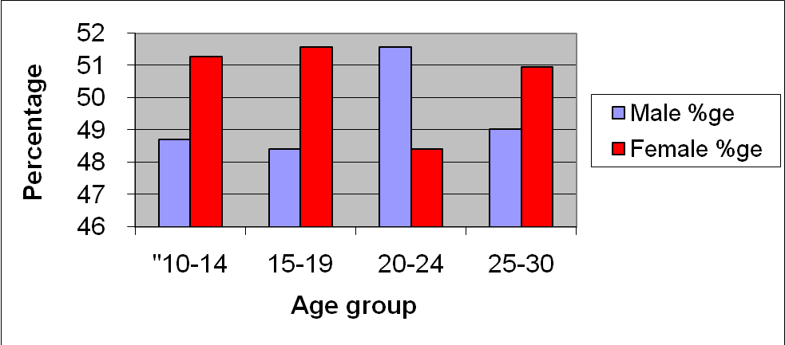
The youth account for 45.5% percent of the District population. Females are more than males in all age groups except 20-24.

Persons with disabilities
Table 2.19: Type of Disability by Age Group for the Population

Type of disability/Age group | 0-17 | 18-30 | 31-59 | 60+ | Total
None | 189,650 | 88,115 | 61,520 | 13,502 | 352,787
Limited use of legs | 672 | 477 | 573 | 392 | 2,114
Loss of legs | 60 | 48 | 72 | 42 | 222
Limited use of arms | 224 | 164 | 308 | 121 | 817
Loss of arms | 13 | 22 | 18 | 12 | 65
Serious problem with back spine | 80 | 87 | 154 | 209 | 530
Hearing difficulty | 386 | 127 | 149 | 250 | 912
Unable to hear (Deafness) | 122 | 60 | 55 | 45 | 282
Sight difficulty | 355 | 190 | 413 | 446 | 1,404
Blindness | 22 | 20 | 32 | 72 | 146
Speech impairment | 161 | 69 | 62 | 23 | 315
Unable to speak (mute) | 134 | 44 | 36 | 27 | 241
Mental retardation | 134 | 112 | 92 | 22 | 360
Mental illness (strange behaviours) | 118 | 137 | 168 | 41 | 464
Epileptic | 73 | 35 | 35 | 12 | 155
Rheumatism | 27 | 17 | 46 | 33 | 123
Others | 84 | 63 | 97 | 34 | 278
Total | 2,665 | 1,672 | 2,310 | 1,781 | 8,428
Source: Source: 2002 Census
Total percentage of the disabled is 2.3%

Figure 2.9 Economic activities by status for the disabled
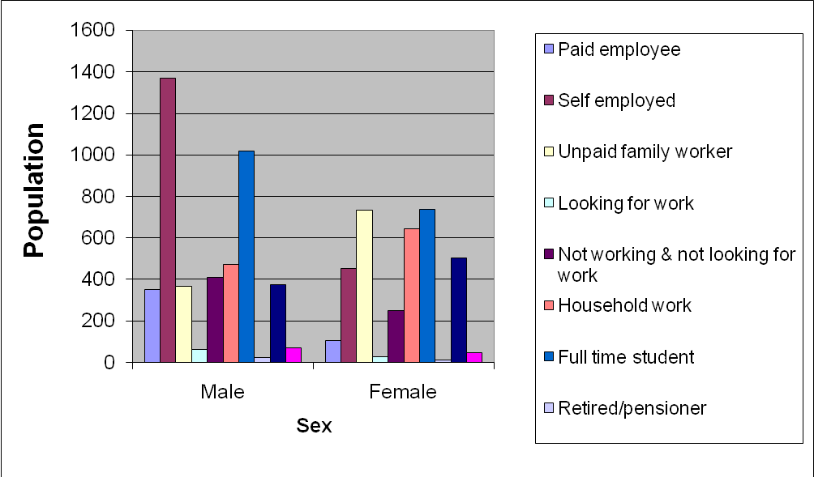

We note from the above graph that most disabled males are self employed, while most females are unemployed female workers. We also observe that we have more male disabled students than females.
The number of disabled males and females looking for work are less than one hundred.

2.2.5 Literacy by sex for the disabled

Table 2.21: Literacy by sex for the disabled
Literacy | Male | Female | Total
Literate | 2,799 | 1,459 | 4,258
Illiterate | 1,293 | 1,704 | 2,997
Total | 4,092 | 3,163 | 7,255

Figure 2.10 Literacy by sex for the disabled

Table 2. 22: Educational attainment by sex for the disabled
Grade Completed | Male | Female | Total
Primary | 2,800 | 1,589 | 4,389
Post Primary | 564 | 265 | 829
Secondary | 407 | 190 | 597
Post Secondary | 157 | 75 | 232
None | 1,388 | 1,822 | 3,210
Total | 4,752 | 3,676 | 8,428

Figure 2.11 Educational attainments by sex for the disabled
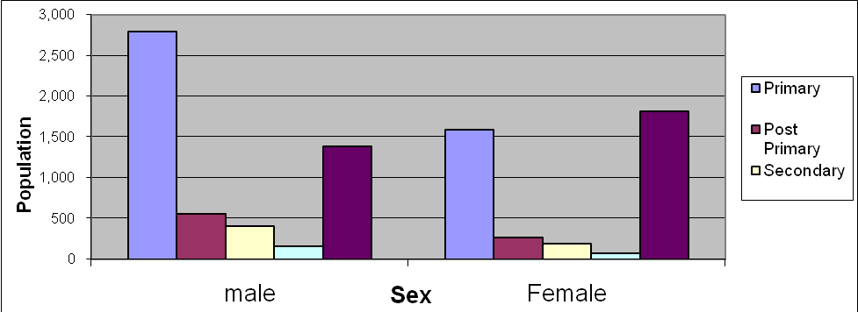
From the above figure we note that there are more males who completed primary education than females. We also note that there are more females who did not go to school at all. For both male and female both that have attained a level of post secondary education are less than five hundred in the whole district.

Figure 2.12: Marital status by sex for the disabled
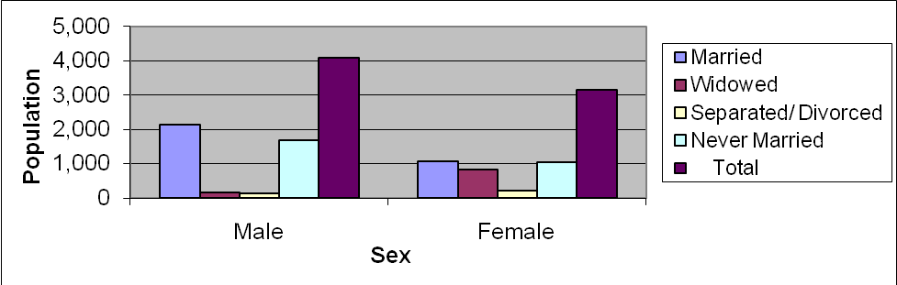
The figure above shows the marital status of people with disabilities in Mbarara by male and female. We note that most disabled men are married while the number of disabled females who are married and those who never married are equal. We also note that most disabled females are widowed. The number of disabled females who separated with their spouses is more than males. A very big percentage also of disabled men is never married.
Orphan hood
Table 2.22: Orphan hood Status for Children (Less than 18 Years Old) by Sub-county for the Population

County | Orphans | Non-Orphans | Don't Know | Total | Father | Mother | Both Parents
 |  |  |  |  | Deceased | Deceased | Deceased
Kashari | 12931 | 74208 | 161 | 87300 | 10513 | 5006 | 2588
Bubaare | 1530 | 8418 | 14 | 9962 | 1252 | 568 | 290
Bukiro | 1038 | 6282 | 0 | 7320 | 863 | 366 | 191
Kagongi | 1360 | 9731 | 19 | 11110 | 1129 | 499 | 268
Kakiika | 1197 | 5764 | 13 | 6974 | 953 | 502 | 258
Kashare | 1779 | 9315 | 27 | 11121 | 1432 | 712 | 365
Rubaya | 2672 | 14607 | 36 | 17315 | 2212 | 1019 | 559
Rubindi | 1531 | 10061 | 29 | 11621 | 1201 | 580 | 250
Rwanyamahembe | 1824 | 10030 | 23 | 11877 | 1471 | 760 | 407
Mbarara Municipality | 5349 | 25631 | 73 | 31053 | 4247 | 2417 | 1315
Kakoba | 2471 | 12620 | 39 | 15130 | 1957 | 1074 | 560
Kamukuzi | 1818 | 8444 | 19 | 10281 | 1480 | 837 | 499
Nyamitanga | 1060 | 4567 | 15 | 5642 | 810 | 506 | 256
Rwampara | 10576 | 63281 | 105 | 73962 | 8645 | 3997 | 2066
Bugamba | 2182 | 14143 | 28 | 16353 | 1839 | 765 | 422
Mwizi | 1673 | 13798 | 12 | 15483 | 1339 | 545 | 211
Ndaija | 2082 | 11633 | 19 | 13734 | 1661 | 820 | 399
Nyakayojo | 2641 | 13236 | 20 | 15897 | 2196 | 1082 | 637
Rugando | 1998 | 10471 | 26 | 12495 | 1610 | 785 | 397
Grand total | 28856 | 163120 | 339 | 192315 | 23405 | 11420 | 5969
Source: Source: 2002 Census

2.2.6 Information, Communication and Transportation
This gives the forms of transport that are commonly used in Mbarara district. It also shows the forms of information communication that are commonly used. The tables are analyzed to give the most common communication channels used.

Table 2.23: Household Transportation
Household Assets and Welfare Indicators | Male Head |  |  | Female Head |  |  | Total
Household Assets and Welfare Indicators | Urban | Rural | Total | Urban | Rural | Total | Urban | Rural | Total
Transport
Own a Motor Vehicle | 1,165 | 783 | 1,948 | 167 | 111 | 278 | 1,332 | 894 | 2,226
Own a Motor Cycle | 698 | 1,645 | 2,343 | 86 | 224 | 310 | 784 | 1,869 | 2,653
Own a Bicycle | 2,315 | 20,171 | 22,486 | 280 | 2,768 | 3,048 | 2,595 | 22,939 | 25,534
Own a Canoe | 30 | 67 | 97 | 9 | 6 | 15 | 39 | 73 | 112
Own a Donkey | 31 | 92 | 123 | 9 | 26 | 35 | 40 | 118 | 158
Do not have any of the above | 9,694 | 24,323 | 34,017 | 3,940 | 10,080 | 14,020 | 13,634 | 34,403 | 48,037

Table 2.24: Household Information Percentage
Type of  information | Urban Households | %ge | Rural Households | %ge | Total
Radio | 14,166 | 26 | 40,932 | 74 | 55,098
Television | 249 | 61 | 161 | 39 | 410
Print Media | 496 | 83 | 101 | 17 | 597
Post mail | 93 | 70 | 39 | 30 | 132
Hand mail | 47 | 28 | 123 | 72 | 170
Word of mouth | 2,590 | 13 | 16,726 | 87 | 19,316
Other | 108 | 28 | 275 | 72 | 383
Source: 2002 Census

Table 1.25: Number and type of communication media in Mbarara
Means of Communication | NUMBER
Radio stations | 10
Courier companies | 3
TV stations | 5
Telecom. Companies | 6
Print media companies | 3
Internet cafes' | 38
Source: Planning Report 2012

CHAPTER THREE: HEALTH SERVICES

3.1 Introduction: HEALTH SERVICES IN GENERAL:

Health Services delivery of the Uganda Minimum Health Care Package follows a decentralized system in tandem with Local Government Administrative arrangement.

This is through a cascade of steps from National and Regional Referral Hospitals, District Hospitals, Health Sub Districts, Health Centre IIIs and Health Center IIs. These offer various services in with limited skills, equipment and supplies.

3.2 Health infrastructure by location and ownership 2012/2013
Subcounty Name | HC IV |  | HC III |  | HC II |  | Hospital
Subcounty Name | Govt | NGO | Govt | NGO | Govt | NGO | Govt | NGO
Bubaare |  |  | 1 |  | 1
Bukiro |  |  | 1 |  | 1
Kagongi |  |  | 1 |  | 1
Kakiika |  |  | 1 |  | 1 |  |  | 1
Kashare |  |  | 1 |  | 1
Rubaya |  |  | 1 |  | 1 | 1
Rubindi |  |  |  |  | 2 | 1
Rwanyamahembe | 1 |  |  |  | 1
Kakoba |  |  |  |  | 1 |  |  | 2
Kamukuzi | 1 |  |  |  | 1 |  | 1 | 1
Nyamitanga |  |  | 1 |  | 2 |  |  | 1
Bugamba | 1 |  |  |  | 4
Mwizi | 1 |  | 1 |  | 4
Ndaija |  |  | 1 |  | 3 | 1
Nyakayojo |  |  | 1 |  | 2
Rugando | 1 |  |  |  | 2
Total | 5 |  | 10 |  | 28 | 3 | 1 | 5
Source: HMISDATABANK 2013

Table 3.2: Health staff in the District 2012/2013
Post | Approved posts | Filled posts | Vacant posts
District Health Officer | 1 | 1 | 0
Assistant DHO (Environmental health) | 1 | 0 | 1
Assistant DHO (maternal child health) | 1 | 0 | 1
Senior Environmental Officer | 1 | 0 | 1
Senior Health Educator | 1 | 1 | 0
Senior medical officer | 3 | 1 | 2
Senior health educator | 1 | 1 | 0
Inspector of Drugs | 1 | 1 | 0
Senior Nursing Officer | 2 | 2 | 0
Senior Clinical Officer | 14 | 10 | 2
Medical Officer | 3 | 1 | 2
Biostatistician | 1 | 1 | 0
Asst. Entomology Officer | 2 | 1 | 1
Nursing Officer / Midwifery | 20 | 7 | 13
Clinical Officer | 12 | 7 | 5
Nursing Officer (psychiatry) | 3 | 0 | 0
Anaesthetic Officer | 3 | 0 | 3
Public Health Dental Officer | 2 | 2 | 0
Health Inspector | 3 | 3 | 0
Radiographer | 1 | 1 | 0
Laboratory technician | 3 | 2 | 1
Theatre Assistant | 6 | 3 | 3
Cold Chain Technician | 1 | 0 | 1
stenographer | 1 | 1 | 0
Stores Assistant | 2 | 1 | 1
TB / Leprosy Assistant | 1 | 1 | 0
Enrolled Midwife | 40 | 38 | 2
Enrolled Nurse | 53 | 42 | 11
Health Assistant | 26 | 12 | 14
Laboratory Assistant | 8 | 8 | 0
Health Information Assistant | 11 | 12 | 0
Nursing Assistant | 58 | 42 | 16
Dental Assistant | 2 | 2 | 0
Office Typist | 1 | 0 | 1
Office attendant | 1 | 0 | 1
Driver | 6 | 6 | 0
Porter | 50 | 5 | 45

Source: HMISDATABANK 2013

These staffing positions include those at the district Headquarters, HC IVs, HC III`s and HC II`s

Table 3.3: Distribution of Health Centre 2012/2013
Health centre | Hospitals | HC. IVs | HC. III | HC. II (Gov’t) | HC. II (NGO) | Total
Kashari HSD | 1 | 1 | 8 | 4 | 7 | 21
Rwampara HSD | 0 | 2 | 3 | 16 | 1 | 22
Municipality HSD | 4 | 1 | 3 | 4 | 1 | 13
Total | 5 | 4 | 14 | 24 | 9 | 56

Source: HMISDATABANK 2013
Therefore access to any form of Health Service is at 60%. Access to Basic Emergency Obstetric care is still poor hence maternal and new born mortalities are high.

Table 3.2: Disease Burden

Disease | Proportion
Malaria | 60%
Materials related diseases | 20%
RTI | 9%
HIV/AIDS | 9%
Diahorria | 5%
Trauma | 4%
Others | 1%

Source: HMISDATABANK 2013

NB: With the prevalence of HIV/AIDS being at 9%, it is an underlying condition in all the above.

Table 3.3: Accessibility of health services
Summary showing Accessibility levels to health services | Male Head |  |  | Female Head
Distance to Nearest Social Services | Urban | Rural | Total | Urban | Rural | Total | Total
Health Facility
Less than 1/2km | 3,786 | 2,883 | 6,669 | 1,426 | 885 | 2,311 | 8,980
1/2 - < 1km | 5,777 | 7,116 | 12,893 | 1,786 | 2,283 | 4,069 | 16,962
1- 5 kms | 3,555 | 19,345 | 22,900 | 1,135 | 5,584 | 6,719 | 29,619
More than 5 kms | 220 | 16,048 | 16,268 | 64 | 4,213 | 4,277 | 20,545
Source: HMISDATABANK 2013

INPATIENT MORBIDITY AND MORTALITY FOR FINANCIAL YEAR 2010/2011
TOP 5 Causes of Morbidity during the financial year 2010/2011 for persons below 5 years |  |  |  |  | TOP 5 Causes of Morbidity during the financial year for persons 5 years and older
Disease/ Condition | # new Diagnoses | As a % of all Diagnoses | # of new diagnoses previous financial year | As a % of all Diagnoses | Disease/ Condition | # of new Diagnoses | As a % of all Diagnoses | # of new diagnoses previous financial yr
1.malaria | 2024 | 23 | 4952 | 49.5 | 1. Malaria | 2176 | 13.7 | 2541
2. Anaemia | 1816 | 21 | 1816 | 18 | 2. Aids | 1204 | 7.6 | 839
3. Pneumonia | 897 | 10 | 889 | 8.9 | 3. Trauma | 895 | 5.6 | 823
4.Perinatla conditions | 673 | 8 | 315 | 3.1 | 4. Anemia | 789 | 5 | 562
5.Respiratory | 467 | 5 | 246 | 2.5 | 5.Tuberclosis | 426 | 2.7 | 362
Total rest of Diagnoses | 2970 | 34 | 3425 | 34.2 | Total rest of Diagnoses | 10435 | 65.5 | 4666
Total all Diagnoses | 8847 |  | 10013 |  | Total all Diagnoses | 15925 |  | (9793

Table 3.3. Estimating target attendance.
Programme / attendance | Attendance Last year | Target this year | Coverage last yr %age
ANC new clients | 24751 | 27226 | 120
Deliveries (in Health Units) | 11358 | 12494 | 55
BCG -under 1 year | 22789 | 25068 | 110
DPT 3 - under 1 year | 17875 | 19662 | 110
Measles - under 1 year | 16169 | 17786 | 110
FP First visits of year (clients) | 25207 | 27728 | 30
OPD new cases (0-4 + 5 and older) | 433787 | 477166 | 105
TB new cases | 829 | 746 | 55

Source: HMISDATABANK 2013

3.4 Public Health / Environmental Health

3:4.1 Environmental Health

Pit latrine coverage is a proxy indicator of this condition is at 90%. However, personal, community and institutional hygiene and sanitation remain a very big problem. As such most of the diseases sanitation related. Dirty water and water borne diseases take a heavy toll on our people.

Table 3.4: Environmental Health Staff

HEALTH SUB-DISTRICT (HSD) | Health Inspectors | Health Assistants
KASHARI  9 Sub-counties | 1 | 8
RWAMPARA  5 Sub-counties | 1 | 5
BUSHENYI MUNICIPALITY  3 Divisions | 2 | 1
DISTRICT HQS | 1 | 0

3:4:3 Health Promotion and Education:

This is a cross – cutting yet underlying activity to source delivery. With advert of FM Radio Stations and other Mass Media Health Promotion and Education has been intensified aimed at creating awareness in the community towards better preventive, curative, health seeking and switching behaviour and utilization of existing services.

Every health workers, political and civic leader is always called to participate. For example Nutrition indicators have been improved; stunting, underweight, wasting and outright severe malnutrition has markedly reduced.

3:4.4 Drugs, Drugs Inspection and Drug Shops

Essential medicines and Supplies have significantly been in stock in most of Public Health Units. The district procures drugs from Joint and National Medical Stores from the ring fenced Primary Health Care (PHC) and Credit Line funds.

There is an alternative source of drugs from private owned drug shops that are regularly supervised by National Drug Authority and the District Drug Inspector.

3:4.5 Vector Control Activities:

The objective of these activities is to mobilize the community for Vector borne diseases control, and vector identification. Indoor residual spraying of mosquitoes is being encouraged particularly in Boarding Schools where most of the Children these days are found, however individual homesteads are also sprayed. A coordinated implementation of home based management of fever program for less than five years children has been undertaken. A total of 50,445 children have been treated by community drug distributors. 72364 mosquito nets have been distributed. This has resulted in reduction of malaria in the said group. However lack of equipment and supplies makes it difficult to carry vector control activities.

3:4:6 T.B / Leprosy Control:

Mbarara District has 29 and 14 T.B treatment and diagnostic health units respectively. In a period of July 2008 to March 2010 a total of 939 T.B Cases have been reported. 64% of them are males. 60% of the totals are HIV/AIDS positive. This makes case finding efficiency for Mbarara District being above 90% compared to the National of 70%. However 30% of the T.B Cases diagnosed come from neighbouring districts who often seek care from Mbarara Regional Referral Hospital. It is important to note defaulter rate is high (45%) and CB dots coverage is only 22%. T.B program is poorly funded by the district and yet the disease is on the increase.
At present there are no recorded cases of leprosy, this is mainly because of stigmatisation.

Table 3.4: Immunizations:
Vaccine | Percentage Coverage
Percentage coverage of BCG | 81.7%
Percentage coverage of DPT3 | 64.4%
Percentage coverage of measles | 59.29%
Percentage coverage of Polio3 | 60.39%
Percentage coverage of TT pregnant | 4.13%
Percentage coverage of TT non-pregnant | 3.88%
Source: HMISDATABANK 2013

3.5. Safe Water coverage

Table 3.5: Source of Drinking water
 |  | Male Head |  |  |  | Female Head |  |  | Total
 |  | Urban |  | Rural | Total | Urban | Rural | Total | Urban | Rural | Total
Source of Drinking Water

Tap/piped water | 12,582 |  | 3,064 |  | 15,646 | 4,085 | 882 | 4,967 | 16,667 | 3,946 | 20,613
Borehole | 99 |  | 2,192 |  | 2,291 | 43 | 798 | 841 | 142 | 2,990 | 3,132
Protected well/spring | 193 |  | 13,134 |  | 13,327 | 107 | 3,470 | 3,577 | 300 | 16,604 | 16,904
Rain water | 39 |  | 898 |  | 937 | 11 | 298 | 309 | 50 | 1,196 | 1,246
Gravity flow scheme | 9 |  | 4,456 |  | 4,465 | 4 | 1,320 | 1,324 | 13 | 5,776 | 5,789
Open water sources | 402 |  | 21,324 |  | 21,726 | 152 | 6,100 | 6,252 | 554 | 27,424 | 27,978
Water truck/water vendor | 7 |  | 139 |  | 146 | 3 | 29 | 32 | 10 | 168 | 178
Other | 7 |  | 185 |  | 192 | 6 | 68 | 74 | 13 | 253 | 266
Source: Water Department, Annual report 2008

Table 3.6: Safe water coverage is 62.2%
Source of drinking water by urban and rural
 | Urban | %ge | Rural | %ge | Total
Tap/Piped water | 16,667 | 81 | 3,946 | 19 | 20,613
Borehole | 142 | 5 | 2,990 | 95 | 3,132
Protected spring | 300 | 2 | 16,604 | 98 | 16,904
Rain water | 50 | 4 | 1,196 | 96 | 1,246
Gravity flow | 13 | 0 | 5,776 | 100 | 5,789
Open water source | 554 | 2 | 27,424 | 98 | 27,978
Water truck/water vendor | 10 | 6 | 168 | 94 | 178
others specify | 13 | 5 | 253 | 95 | 266
Source: Water Department, Annual report 2010

Table 3.7: Latrine coverage
Toilet facilities by urban and rural
Type of latrine facility | Urban | %ge | Rural | %ge | Total
Covered pit latrine/private | 2,403 | 7 | 31,898 | 93 | 34,301
Covered pit latrine/shared | 10,601 | 37 | 18,430 | 63 | 29,031
VIP latrine/private | 517 | 34 | 1,025 | 66 | 1,542
VIP latrine/shared | 1,790 | 67 | 865 | 33 | 2,655
Uncovered pit latrine | 598 | 13 | 4,103 | 87 | 4,701
Flush toilet/Private | 952 | 83 | 196 | 17 | 1,148
Flush toilet/shared | 823 | 78 | 237 | 22 | 1,060
Bush | 43 | 3 | 1503 | 97 | 1,546
others specify | 22 | 18 | 100 | 82 | 122
Source: Health Department 2008

Table 3.8: Public Health/ Environmental Health Education

No of health inspectors | 5
No of sensitization/Health Education meetings held by theme, in a year | 36
Proportion of building plans approved | 10%
Number of inspections of food vendors conducted | 816
Number of village health teams trained | 14
Percentage of households using hand-washing facilities | 25%
Percentage of households with kitchen | 65%
Percentage of households with bathroom | 69%
Percentage of households with boiled / treated drinking water | 70%
Percentage latrine coverage | 90%
Source: Health Department

Table 3.9: Tuberculosis, and Onchocerciasis
Number of patients suffering from TB | 1189
TB District coverage as compared to the national | 85
Number of TB diagonistic centres | 14
Number of TB treatment centres | 28
Source: HMISDATABANK 2013

Table 3.10: Maternal and Child health (MCH)

Supervised deliveries by skilled personnel (proportion of supervised deliveries to those who attended antenatal) | 40%
No of pregnant mothers receiving antenatal and postnatal care | 17267
Contraceptive prevalence rate/No. of mothers practicing family planning | 24791 (30%)
Total number of deliveries | 8740
Number of HIV positive deliveries | 768
Number of HIV Positive deliveries given (and swallowed) NVP during labour | 275
Number of HIV positive deliveries swallowed AZT and Nevirapine | 10
Number of HIV positive deliveries receiving other regimen for PMTCT (specify regimen) | 26
Number of positive mothers initiating exclusive breastfeeding | 546
Source: HMISDATABANK 2013

AIDS Control (Prevalence, control and treatment)

Prevalence rate for Mbarara District is 5.9%. In the district, urban centres have a prevalence rate of 10.96% and 5.8% for rural.
Prevalence rate among females | 8%
Prevalence rate among males | 5%
Number of VCT service centres | 32
Number of people counselled | 54476
Number of people tested for HIV | 53243
Number of people tested HIV positive | 6219
Source: HMISDATABANK 2013

Treatment
Number of HIV positive people on ARVs | 848
Number of health facilities offering PMTCT services | 29
Number of ART service centres | 7
Source: HMISDATABANK 2013

HIV Counselling and Testing
Number of new ANC clients | 15865
Number of pregnant women tested for HIV | 10918
Number of women tested HIV positive | 1212
Male partner involvement | 2%
HIV/AIDS prevalence rate | 5.9%
Number of HIV counselling centres | 32
Number of people tested positive | 6%
Number of HIV-positive people on ARVs | 2385
Number of partners tested for HIV | 692
Number of partners tested HIV positive | 93
Number of HIV positive pregnant women received Nevirapine (NVP) only | 804
Number of HIV positive pregnant women started on Zidovudine(AZT) and received NVP
Number of HIV positive pregnant mothers receiving ART(Triple therapy) | 130
Number of pregnant mothers receiving other regimen for PMTCT (specify regimen) | 125
HMISDATABANK 2013

CHAPTER 4: EDUCATION AND SPORTS

4:1:0 EDUCATION IN GENERAL

Table: 4.2: Primary School enrollment by school per class and corresponding classrooms
Sub  county | P1 |  | P2 |  | P3 |  | P4 |  | P5 |  | P6 |  | P7 |  | Total
 | Enrol. | Trs | Enrl. | Trs | Enrl. | Trs | Enrl. | Trs | Enrl. | Trs | Enrl. | Trs | Enrl. | Trs
Nyakayojo | 1734 | 35 | 802 | 25 | 752 | 25 | 741 | 25 | 646 | 24 | 575 | 23 | 436 | 20 | 5686
Mwizi | 1653 | 27 | 955 | 18 | 849 | 18 | 946 | 16 | 616 | 15 | 556 | 15 | 352 | 13 | 5927
Kakiika | 433 |  | 238 |  | 248 |  | 224 |  | 200 |  | 127 |  | 99 |  | 1579
Rugando | 1709 | 31 | 793 | 22 | 771 | 22 | 834 | 22 | 605 | 20 | 590 | 20 | 409 | 20 | 5687
Ndeija | 1860 | 30 | 727 | 19 | 848 | 19 | 898 | 20 | 708 | 19 | 665 | 19 | 488 | 18 | 6092
Bugamba | 1882 | 32 | 952 | 21 | 896 | 21 | 969 | 21 | 705 | 20 | 652 | 20 | 500 | 20 | 6504
Bubaare | 886 | 16 | 518 | 11 | 533 | 13 | 607 | 11 | 405 | 11 | 380 | 11 | 259 | 11 | 3588
Rubaya | 969 | 15 | 560 | 12 | 619 | 12 | 543 | 11 | 419 | 11 | 343 | 11 | 258 | 11 | 3711
Bukiro | 1082 | 16 | 422 | 8 | 430 | 8 | 406 | 8 | 300 | 8 | 282 | 8 | 171 | 8 | 3093
Rubindi | 911 | 18 | 530 | 12 | 490 | 12 | 528 | 12 | 464 | 12 | 381 | 13 | 306 | 12
Biharwe | 853 | 16 | 476 | 11 | 472 | 11 | 531 | 10 | 375 | 11 | 370 | 10 | 232 | 9 | 3309
Kagongi | 1203 | 20 | 568 | 12 | 582 | 13 | 549 | 12 | 457 | 12 | 389 | 12 | 300 | 12 | 4078
Rwanyamahembe | 1089 | 18 | 541 | 15 | 576 | 15 | 560 | 15 | 433 | 14 | 420 | 15 | 309 | 14 | 3928
Kashare | 1277 | 23 | 712 | 17 | 714 | 18 | 719 | 16 | 544 | 15 | 451 | 15 | 375 | 15 | 4792
Source: Inspection Report 2013

Table: 4.3: PLE RESULTS 2013

SUB/COUNTY | DIV.I | DIV.II | DIV.III | DIV.IV | DIV.U | ABS | TOTAL
KAKIIKA | 33 | 124 | 10 | 1 | 0 | 4 | 172 | 97.6% | 1st
BUBAARE | 94 | 219 | 35 | 14 | 11 | 15 | 388 | 93.2% | 9th
RUBAYA | 33 | 182 | 184 | 48 | 30 | 24 | 332 | 88.8% | 13th
BIHARWE | 115 | 251 | 33 | 18 | 9 | 4 | 431 | 96.9% | 3th
RWANYAMAHEMBE | 89 | 334 | 56 | 15 | 11 | 9 | 514 | 96.1% | 5rd
BUKIRO | 24 | 127 | 26 | 05 | 01 | 05 | 188 | 96.8% | 4th
RUBINDI | 86 | 251 | 33 | 14 | 12 | 11 | 407 | 94.3% | 6th
KAGONGI | 43 | 260 | 66 | 32 | 15 | 14 | 431 | 93% | 10th
KASHARE | 181 | 264 | 71 | 30 | 28 | 22 | 596 | 91.6% | 12th
NYAKAYOJO | 84 | 346 | 72 | 59 | 57 | 21 | 639 | 87.7% | 14th
NDEIJA | 217 | 443 | 50 | 26 | 12 | 9 | 757 | 97.2% | 2nd
BUGAMBA | 48 | 366 | 100 | 33 | 22 | 17 | 586 | 93.3% | 8th
MWIZI | 31 | 234 | 62 | 29 | 16 | 15 | 387 | 91.9% | 11th
RUGANDO | 101 | 389 | 93 | 31 | 23 | 15 | 652 | 94.1% | 7th
TOTAL | 1180 | 3792 | 755 | 337 | 242 | 174 | 6480

Source: UNEB PLE RESULTS 2013

Table 4.4: Key indicators for schools
No. of primary School | 197
No. Vocational school | 3
No. of permanent classrooms constructed | 582
No. Of temporary classrooms | 1117
No. of latrine stances | 1829
Pupil : Class room ratio | 37:1
Pupil: Teacher ratio | 36:1
Pupil : Desk ratio | 6:1
Pupil: Textbook Ratio | 5:1
No. Of Inspectors | 4
Inspector : Primary school ratio | 1:38
Number of schools inspected | 296
Number of inspection report produced | 13
% of recommendations implemented | 45%
No. of school Management committees (SMC) | 197 (100%)
Source: Education department inspection Report 2013

CHAPTER 5: WORKS AND TECHNICAL SERVICES

5:1:0 WATER
Current Staffing of the District water office
- Senior Water Engineer …………………………………………………...1
- ADWO Mobilization ……………………………………………………. 1
- Senior Assistant Engineering Officer …………………………………......1
- Assistant Engineering Officer …………………………………………....1
- Borehole Maintenance Technician…………………………………….......1
- Office typist …………………………………………………………........1
- Driver ……………………………………………………………………..1

5:1:1 MBARARA DISTRICT SAFE WATER COVERAGE

The Department of water is mandated with the responsibility of providing safe water and sanitation facilities to the population of Mbarara District. The Current safe water coverage is 68% that is serving the population of 152,900 out of the total population of 291,350 (this figure excludes the NWSC – the Municipality. The Department is focused to increasing the coverage to 100% by the year 2015 as the main goal.

Type of water sources in the District: Boreholes, shallow wells, valley Dams, Protected springs, Community tanks, Household (HH) tanks, GFS taps, piped water.

SUB-COUNTY | Functional Boreholes | Shallow Well | Prot. Spring | Piped water | Valley tanks | HH Tanks | GFS Taps | Com Tanks | Population Served | Coverage
Bubare | 16 | 17 |  | 3 | 1 | 144 |  | 6 | 6,700 | 36.5
Bukiro | 1 | 2 | 27 |  |  | 30 | 37 | 1 | 8,250 | 61.3
Kagongi | 3 | 6 | 45 |  | 1 | 10 | 36 | 1 | 11,250 | 57.7
Kakiika | 18 | 6 |  | 10 | 1 | 70 |  |  | 6,150 | 41.9
Kashare | 19 | 4 |  |  | 4 | 268 | 1 | 1 | 5,330 | 26.5
Rubaya | 18 | 6 |  | 2 | 3 | 630 |  | 2 | 16,560 | 50.1
Biharwe | 13 |  |  | 10 | 2 | 105
Rubindi | 3 | 5 | 32 |  | 1 | 108 | 54 |  | 20,550 | 97.2
Rwanyamahembe | 16 | 6 | 14 | 8 | 1 | 140 | 10 |  | 14,450 | 64.6
Bugamba |  |  | 46 |  |  | 340 |  | 15 | 24,450 | 84.2
Mwizi |  |  | 52 |  |  | 45 | 118 |  | 8,292 | 31.8
Ndeija | 2 | 4 | 84 |  |  | 145 | 59 | 2 | 22,950 | 112.8
Nyakayojo |  | 6 | 36 |  |  | 65 | 147 |  | 16,650 | 55.7
Rugando | 16 |  | 46 |  |  | 65 | 147 |  | 27000 | 118.2
Total | 125 | 62 | 382 | 33 | 14 | 2165 | 609 | 28 | 188582 | 640.8
Table 5.1: Water coverage by source and sub county (August 2013)
5.2: ROADS
Table 5.2.2: COMMUNITY ACCESS ROADS
County | Subcounty | KM
Kashari | Rubaya | 189.8
 | Rubindi | 292
 | Kakiika | 195.6
 | Bubaare | 250
 | Kagongi | 183
 | Kashare | 249
 | Rwanyamahembe | 235
 | Bukiro | 179.5
 | Biharwe | 150.5
 | Total | 1924.4
Rwampara | Mwizi | 263
 | Bugamba | 270
 | Nyakayojo | 254
 | Rugando | 213.6
 | Ndeija | 192
 | Total | 1192.6
District | Grand Total | 3117

Table 5.2.3 SCOPE OF FEEDER ROAD NETWORK
Location |  | Road Name | No.of culvert lines | No.of Bridges | Length (Km) | Class | Surface (Type) | Condition | Accessibility
County | Sub-County
Kashari | Bubaare/ Rwanyamahembe | Ekiyenje - Nkaka | 19 |  | 14.5 | I | Gravel | Good | Motorable
Kashari | Bukiro/Rubindi/ Kagongi | Bukiro-Rubare-Kagongi - Rubindi | 52 |  | 40.0 | II | Gravel | Good | Motorable
Kashari | Bubaare/ Bukiro/ Rwanyamahembe | Kashaka-Karuyenje | 40 |  | 21.5 | I | Gravel | Good | Motorable
Kashari | Kagongi | Ruhumba-Bwengure | 06 |  | 11.5 | II | Gravel | Good | Motorable
Kashari | Rwanyamahembe/ Kashare | Rutooma-Kashare-Mutonto | 05 |  | 11.5 | I | Gravel | Good | Motorable
Kashari | Rubindi | Rubindi-Rubare-Mile 22 | 12 |  | 10.0 | I | Gravel | Good | Motorable
Rwampara | Ndeija/ Bugamba | Nyamukana - Kibaare - Byanamira | 117 |  | 30.0 | I | Gravel | Fair | Motorable
Rwampara | Ndeija | Ndeija - Nyindo - Nyeihanga | 11 | 02 | 7.5 | I | Gravel | Good | Motorable
Rwampara | Mwizi | Mwizi-Kikunda-Omukatojo | 08 |  | 14.0 | I | Earth | Fair | Motorable
Rwampara | Nyakayojo/Rugando/ Bugamba | Rwakishakizi-Karangara-Bugamba-Rukandagye | 49 |  | 20.5 | I | Gravel | Fair | Motorable
Rwampara | Nyakayojo/Mwizi | Nyakayojo - Kichwamba | 62 |  | 18.5 | I | Gravel | Fair | Motorable
Rwampara | Rugando/Ndeija | Nyakaguruka - Ihunga - Kabutaare | 08 |  | 9.5 | I | Earth | Fair | Motorable
Rwampara | Ndeija/ Bugamba | Nyamukana - Kashuro - Kitojo - Bugamba | 30 |  | 26.0 | II | Earth | Fair | Motorable
Rwampara | Mwizi/Bugamba | Rweibogo - Karamurani | 05 |  | 8.0 | I | Earth | Fair | Motorable
Rwampara | Nyakayojo | Mile 2 - Rwarire - Kibona | 14 |  | 11.0 | I | Gravel/ Earth | Fair | Motorable
Kashari | Rwanyamahembe/ Bubaare | Bwizibwera - Nyapikye-Kitookye-Rwenshanku | 13 |  | 19.0 | II | Gravel | Fair | Motorable
Kashari | Rubaya | Rubaya - Akasusano | 12 |  | 10.0 | I | Gravel | Good | Motorable
Kashari | Rubaya | Bunenero - Kaguhanzya-Kyamatambarire | 18 |  | 11.0 | I | Gravel/ Earth | Good | Motorable
Rwampara | Rugando | Kinoni - Ngoma | 11 | 01 | 5.0 | I | Gravel | Good | Motorable
Rwampara | Bugamba | Rukuzi - Kakongora - Binyuga - Ngugo | 10 |  | 12.0 | II | Earth | Poor | Non-motorable
Kashari | Biharwe/Kakiika | Rwagaaju - Kishasha | 05 |  | 10.0 | I | Earth | Fair | Motorable
Kashari | Kakiika | Kabagareme - Katebe-Kanyeganyegye | 12 |  | 7.0 | I | Earth | Fair | Motorable
Kashari | Kagongi | Bugarama - Kagongi | 06 |  | 12.0 | II | Earth | Fair | Motorable
Kashari | Biharwe | Ekihangire - Lake Mburo National Park | 8 |  | 5.0 | II | Earth | Fair | Motorable
Kashari | Rwanyamahembe | Kanyeganyegye - Runengo | 01 |  | 9.0 | I | Earth | Poor | Motorable
Kashari | Nyakayojo/Bugamba Mwizi | Kikokoma - Ibumba - Ryamiyoga | 20 |  | 20.0 | I | Earth | Fair | Motorable
Kashari | Kashare | Rubindi-Kashare | 08 |  | 10.0 | II | Earth | Fair | Motorable
Kashari | Kagongi | Ntura - Nyaminyobwa-Nkondo | 06 |  | 9.0 | I | Earth | Poor | Motorable
Kashari | Kashare | Amabaare - Nyabisirira - Kiruhura District Border | 02 |  | 8.0 | II | Earth | Poor | Non-motorable
Rwampara | Bugamba | Kabirizi - Katerero - Kabarama | 09 |  | 7.0 | II | Earth | Poor | Motorable
Rwampara | Mwizi/Bugamba | Bushwere - Rwentojo - Bugamba | 20 |  | 8.0 | II | Earth | Fair | Motorable
Rwampara | Nyakayojo | Ibaare - Kishenyi - Kichwamba | 01 | 01 | 8.0 | II | Earth | Fair | Motorable
Rwampara | Nyakayojo | Nyamiyaga - Kibona | 06 |  | 7.0 | II | Earth | Poor | Motorable
Kashari | Rubindi | Omurutaisire - Kabare - Mile 26 | 01 |  | 5.0 | II | Earth | Fair | Motorable
Rwampara | Ndeija/ Bugamba | Buteraniro-Nyakikara-Kongoro-Kashasha | 27 |  | 19.0 | I | Earth/ Gravel | Fair | Motorable
 |  | Total |  |  | 455.0
Source: District Roads status Report 2013

CHAPTER 6: NATURAL RESOURCES

6.1 Environmental sanitation

Item | No. | Comment
Number of solid waste collection points | 71 | Within Mbarara Municipality
Number of landfills | 1 | Kenkombe sanitary Mbarara Municipal Council
Length of storm drainage | 15 km | In Mbarara Municipality
Number of waste disposal points in LG | 12 | In 4 Town boards
Number of abattoirs by condition | 2 | No functional waste water treatment facility

    - State of the environment in the district
Prevalent pollution by type

Type of pollution | Location/Sub-County
Waste water pollution | Urban areas mainly Mbarara Municipal Council and upcountry rural growth centres
Non-point serve pollution | District wide
Industrial pollution | Milk factories and Nile breweries in Mbarara Municipal Council
Agro-Chemical pollution (Acaracides) | District wide due to location of spraying places near water bodies or wetlands

6.1.2 Factories
Category | No | Comment
Milk factories | 6 | Challenges of waste water management and disposal of plastic/polythene materials.
Steel rolling factories | 1 | Safety hazards No protective fears
Bakeries | 5 | Poor housekeeping condition
College Industries | 10 | Environmental standards not adhered to due to failure to conduct environmental audits

    - Waste management
Item | No | Comment
Number of bunkers | 6
Number of garbage truck | 10 | One with self loading provision
Number of refuse skips | 71 | Overflowing of garbage
Number of factories/petrol stations with waste water treatment facilities | 20 | Existing of oil interceptors to newly constructed stations mitigate water pollution.

  - Tree planting
Item | No | Location | Type trees
Nursery beds established and maintained | 41 | District wide | Assorted tree species with variety of fruits
Trees planted annually | 50,000 | District wide | Mainly pine and eucalyptus
Commercial tree growers | 85 | District wide | Mainly involved in pine for  carbon Roding
Common tree species | 2 | District wide | Pine supply, eucalyptus
Common pests and diseases of trees | 2 | Wilt and bright | pines
Tree species planted in district | 5 | District wide | Dominant species fines eucalyptus mangoes and orange

6.2.1 Charcoal/timber trade
Item | Location | No | Comment
Licensed charcoal dealers | District wide | 38 | Not involved in tree planting
Licensed timber dealers | Urban area | 45 | Mainly involved in eucalyptus timber, soft wood and Hard wood from DRC
Area under wild game (gazetted) – Lake Mburo National Park=260km3 but also lies in Kiruhura and Isingiro District
6.2.3 Location of Rivers, Swamps and Lakes
Rivers/wetlands/water bodies | Location/sub-county | Status Permanent/ seasonal
River Rwizi wetlands | Rwampara and part of Kashari | Counties-Permanent
Rubindi Wetland | Rubindi/Kagongi | Permanent
Nyakishara wetland | Bubare,Rwanyamahembe | Permanent
Rwenjuro wetland | Kashare/Rubandi | Permanent
6.2.4 Land degradation problems and causes
Issue | Causes | Area coverage
Loss of soil fertility | Poor agricultural | District wide
Soil erosion | Poor & bus burning | Rwampara County
Deforestation | Search for forest products | District wide
Poor solid waste management | Indiscrimate dumping of waste | Urban area
Bush burning | Need for fresh pasture, malice and ignorance | Rwampara county.  Bubare, Biharwe and Kakiika subcouties.

  - Forestry
Type of forest by size (Gov’t/private forest reserves, District forest reserves)
Name of forest | Size of forest (ha) | District Forest reserve
Bugamba | 1210 | Mbarara
Rwoho | 9073 | Mbarara, Isingiro/Ntungamo
Kyahi | 4090 | Mbarara Isingiro
Nyamityobora | 91 | Mbarara MC
Ruti | 119 | Mbarara MC
Bwizibwera | 28

- Estimated land coverage planted with tree annually=300 acres annually
- Gazetted forest reserves=6 reserves
- No of households promoting fuel saving technologies =312 households

6.4.1State of forestry
- Deforestation-estimated rate of deforestation (area) = 12%
- Re-aforestaion-estimated rate of re-a forestation (area) 06%
- A forestation = 11%
- Agro forestry – number of households promoting agroforestry 213
- Common timber tree species promoted in district Pines, eucalyptus, Meosopsis and mvule
- Pests and diseases prevalent in forestry enterprise-weevils, mosaic and bright.

6.4.2 Tree Planting
Tree Nursery bed sites according to ownership

 | OWNERSHIP
Seedlings data annually | Government/public | Institutional/ Schools/NGO’s | Groups/CBO | Individual
No. of nursery beds | 1 main Nursery (NFA) | 10 | 35 | 60
No. of commercial tree growers | 1 i.e. RHOHO/Kyahi forest reserve | 1 i.e. CECOD | Not yet known | Not yet known
No. of seedlings raised | 100,000 | 50,000 | 100,000 | 100,000
No. of seedling sold | 150,000 | NA | 80,000 | 90,000
No. of seedlings | 150,000 | 40,000 | 80,000 | 100,000

Natural and planted forests
Name of forest | Location (sub-county | Type of forest | Total (ha) acreage | Are (ha) planted | Area (ha) encroached | Area (ha)  unplanted | Common tree species
Bugamba | Bugamba/ Mwizi | Soft wood | 1210 | 1210 | - | - | Pines/ Eucalyptus
Rwoho | Mwizi | Softwood | 3000 | 3000 | - | - | Pines/ Eucalyptus
Kyahi | Biharwe/Kakiika | Eucalyptus | 2000 | 1000 | - | 1000 | Eucalyptus
Nyamityobora | Mbarara M.C | Eucalyptus | 91 | 64 | 27 | 27 | Eucalyptus
Ruti | Mbarara MC | Eucalyptus | 119 | 80 | 39 | - | Eucalyptus
Bwizibwera | Rwanyamahembe | Eucalyptus | 28 | 20 | 8 | - | Eucalyptus

CHAPTER 7: COMMUNITY BASED SERVICES

7.0 GENERAL COMMUNITY ISSUES
The Department contributes to the achievements of the District’s mission which is to serve the community through the coordinated delivery of services which focus on National and local priorities in order to promote sustainable social and economic development of the district.

The department has been at the forefront of community mobilization and sensitization for economic, social and political development. Over 500 women, youth and PWDs leaders have been mobilized and sensitized on income generating activities.

FAL programme has raised the literacy level up to 85%. It is mainly the females who attend these FAL classes as opposed to males.

7.1 GENDER AND CULTURE
Gender mainstreaming training meetings targeting both district and sub county staff have been conducted in the 14 sub counties of the district. As a result, Gender has been mainstreamed in district programmes.

The department has also carried out advocacy on the rights of women-generally and the education of the girl child specifically.

Table 7.1: Functional Adult literacy programme
 | Number of learners |  | Total
Sub-county | Male | Female
Rubaya | 133 | 253 | 386
Kakiika | 186 | 380 | 566
Nyakayojo | 132 | 637 | 769
Kagongi | 141 | 462 | 603
Ndeija | 54 | 226 | 283
Biharwe | 74 | 123 | 227
Bubaare | 35 | 162 | 197
Bukiro | 24 | 175 | 199
Mwizi | 255 | 1110 | 1345
Kashare | 26 | 221 | 247
Rubindi | 79 | 201 | 280
Rugando | 187 | 876 | 1063
Rwanyamahembe | 179 | 268 | 447
Bugamba | 129 | 343 | 472
Total | 1634 | 5437 | 7071
Total No. of FAL instructors |  |  | 363
Total No. Of FAL classes |  |  | 363

Source: Community performance report

7.2 ELDERLY AND DISABILITY
The homes of PWDs have been visited and registration of PWDs conducted.
Also PWDs together with Elderly persons have been mobilised and sensitised to engage in viable IGAs.

CHAPTER 8: PRODUCTION AND MARKETING

8.1 Agriculture
The agricultural production office, performs the following functions
Monitoring, supervising and providing technical back up to field programmes and staff.
- Coordinating the information and development of strategic plan and monitoring its effective implementation.
- Ensuring timely preparation and submission of annual and quarterly work plans, budgets and reports.
- Identifying, procuring and disseminating appropriate technologies to farmers, producers and users.
- Ensuring proper management of production facilities i.e. vehicles, office equipments promoting, attracting and supporting investors, authorizing and licensing traders.
- Organizing and attending committee meetings and council sessions.

8:1:1 Crops

Table 8.1: Common crops grown in Mbarara

Crop | Consumption percentage
Perennial crops  - Bananas  - Coffee | 60%  01%
Pulses  - Beans  - G/nuts  - Field pees | 50%  40%  20%
Root Crops  - Cassava  - Irish Potatoes  - Sweet Potatoes | 40%  20%  80%
Vegetable  Tomatoes  Cabbage  Amaranthus (Dodo)  Carrots  Onion | 20%  20%  80%  10%  20%

8.2 Livestock and Veterinary Services

Table 8.2: Number of livestock per sub county by type
County | Sub-County | Cattle | Goats | Sheep | Pigs | Dogs | Poultry
Kashari | Rwanyamahembe | 19,000 | 58252 | 9514 | 941 | 3317 | Data not available
Kashari | Kakiika | 7,200
Kashari | Kashare | 10,000
Kashari | Bubaare | 15,000
Kashari | Rubaya | 11,000
Kashari | Kagongi | 4,000
Kashari | Biharwe | 10,000
Kashari | Bukiro | 3,500
Kashari | Rubindi | 6,000
Kashari | Sub- Total | 85,700 | 19070 | 5796 | 1838 | 3865 | Data not available
Rwampara | Nyakayojo | 12,000
Rwampara | Mwizi | 1,150
Rwampara | Bugamba | 7,200
Rwampara | Ndeija | 7,000
Rwampara | Rugando | 10,000
Rwampara | Sub-Total | 37,350
Municipality | Kakoba | 60 | 2028 | 158 | 460 | 316 | Data not available
Municipality | Nyamitanga | 80
Municipality | Kamukuzi | 140
Municipality | Sub-Total | 280
Municipality | Total | 123330 | 79350 | 15460 | 3239 | 6378 | 1495

Source: Mbarara District Animal Census as at 30th December 2006

8.3 Fisheries

The fisheries Department takes care of fish farming in Mbarara District. The number of fish ponds in Mbarara District is 420 with varying sizes between 100m² – 3000m².

The average production is at 800.000 fish per harvest which take place twice a year (every 6 months) valued at 240.000.000. However much of this fish are consumed at family level without recording its value.

8:3:1 Types of Fish stocked in the ponds are:
Tilapia Nilotic, clarias M.carp and T zillii

8.3.2 Major diseases and predators
The most common disease is the fungal infection. Predators include snakes and birds

8.3.3 Fish Farmers by Sex, Location, Fish ponds (Appendix)

8.4 Agricultural Projects and Programs (PMA and NAADS)

Table 8.5: Number of Beneficiaries by Project type and Sex
Sub -County | Type of enterprise | No. of Groups | Male | Female | Total | No. of Benefiting Households
Rugando | Goad Rearing | 1 | 7 | 0 | 7 | 7
Rugando | Bee Keeping | 10 | 124 | 156 | 279 | 207
Rugando | Diary Production | 2 | 19 | 22 | 41 | 35
Rugando | Pig Rearing | 11 | 15 | 199 | 215 | 210
Rugando | Vegetable Production | 3 | 37 | 30 | 67 | 50
Rugando | Irrigation Demonstration | 1 | 3 | 6 | 9 | 9
Rugando | Passion Fruit Production | 1 | 4 | 5 | 9 | 9
Rugando | Banana Improvement | 4 | 27 | 20 | 47 | 47
Sub-Total |  | 33 | 236 | 438 | 674 | 574
Ndeija | Fish farming | 2 | 19 | 11 | 30 | 29
Ndeija | Pig rearing | 2 | 1 | 9 | 10 | 10
Ndeija | Goat rearing | 16 | 61 | 124 | 185 | 147
Ndeija | Bee Keeping | 1 | 6 | 4 | 10 | 10
Ndeija | Irrigation Demo/Fish | 1 | 13 | 3 | 16 | 15
Ndeija | Passion Fruit | 1 | 12 | 8 | 20 | 15
Ndeija | Vegetable | 1 | 2 | 14 | 16 | 16
Ndeija | Pineapple | 1 | 9 | 17 | 17 | 17
Sub-Total |  | 25 | 123 | 190 | 304 | 259
Rubaya | Beef rearing | 1 | 4 | 15 | 19 | 19
Rubaya | Goat rearing | 17 | 163 | 206 | 369 | 283
Rubaya | Bee Keeping | 2 | 25 | 15 | 40 | 33
Rubaya | Fruit trees | 2 | 20 | 21 | 41 | 39
Rubaya | Passion Fruit | 3 | 20 | 30 | 50 | 27
Rubaya | Beans Production | 0 | 0 | 17 | 17 | 17
Rubaya | Banana Improvement | 1 | 16 | 4 | 20 | 20
Total |  | 26 | 248 | 308 | 556 | 438
Kakiika | Bee keeping | 2 | 50 | 46 | 96 | 96
Kakiika | Pig rearing | 8 | 33 | 151 | 184 | 127
Kakiika | Goat rearing | 11 | 67 | 127 | 194 | 124
Total |  | 21 | 150 | 324 | 474 | 347
Biharwe | Irish Potato growing | 10 | 52 | 123 | 175 | 175
Biharwe | Tomato growing | 2 | 32 | 28 | 60 | 60
Biharwe | Bee keeping | 3 | 30 | 25 | 55 | 55
Biharwe | Pig rearing | 4 | 10 | 35 | 45 | 40
Biharwe | Banana improvement | 2 | 26 | 14 | 40 | 40
Biharwe | Irrigation Demonstration | 2 | 4 | 15 | 19 | 15
Biharwe | Goat rearing | 3 | 24 | 36 | 60 | 55
Total |  | 26 | 178 | 276 | 454 | 440
Nyamitanga Division | Goat rearing | 7 | 46 | 92 | 144 | 111
 | Pig rearing | 7 | 24 | 75 | 99 | 80
 | Bee Keeping | 1 | 6 | 10 | 16 | 6
 | Fish farming | 1 | 9 | 5 | 14 | 5
 | Mushrooms | 1 | 4 | 28 | 32 | 28
 | Vegetable Growing | 4 | 37 | 39 | 76 | 54
Total |  | 21 | 126 | 249 | 381 | 284
Rubindi | Pig Rearing | 16 | 72 | 139 | 211 | 198
Rubindi | Bee Keeping | 3 | 27 | 18 | 45 | 37
Rubindi | Goat Rearing | 7 | 43 | 70 | 113 | 111
Total |  | 26 | 142 | 327 | 369 | 346

8.5 Extension Services

8.6 Trade
Agro processing/Value addition industries in Mbarara

Sub county Name | No. of Milk Coolers | No. of Grinding Mills | No. of Grain Mills | No. of Maize mills | No. of Timber Modeling | No. of Coffee processing | No. Warangi  Processing | No. of Millet  Processing
Bubaare | 1 | 2 | 0 | 0 | 0 | 0 | 0 | 0
Rugando | 1 | 0 | 2 | 0 | 0 | 0 | 0 | 0
Nyakayoojo | 0 | 0 | 0 | 1 | 0 | 0 | 0 | 0
Bukiro | 0 | 0 | 0 | 4 | 0 | 0 | 0 | 0
Rubindi | 1 | 0 | 6 | 0 | 1 | 0 | 0 | 0
Kakiika | 0 | 0 | 0 | 3 | 0 | 0 | 0 | 0
Rubaya | 0 | 0 | 0 | 3 | 0 | 0 | 0 | 0
Rwanyamahembe | 5 | 0 | 0 | 4 | 0 | 0 | 0 | 2
Ndeija | 0 | 0 | 0 | 3 | 0 | 9 | 0 | 0
Biharwe | 4 | 0 | 2 | 0 | 0 | 0 | 0 | 0
Mwizi | 0 | 0 | 1 | 0 | 0 | 0 | 1 | 0
Kagongi | 0 | 0 | 16 | 0 | 0 | 0 | 0 | 0
Kashare | 0 | 0 | 4 | 0 | 0 | 0 | 0 | 0
Bugamba | 0 | 0 | 2 | 0 | 0 | 0 | 0 | 0
Source: Commercial Officer Report Dec 2010

List of SACCOS by membership, shares and working capital
SACCO Name | Members | Shares | Savings | Loans
Kakiika Abamwe | 337 | 8,970,000 | 9,103,186 | 35,527,400
Keirungu Sacco | 684 | 28,300,000 | 46,919,304 | 50,023,948
Rwenyaga Parent Sacco | 658 | 6,880,000 | 43,489,650 | 69,904,450
Kakoma United Farmers | 208 | 2,540,000 | 21,359,550 | 10,470,000
Rubingo Farmers | 258 | 15,140,000 | 10,228,777 | 37,673,700
Kinoni | 170 | 1,941,000 | 5,473,150 | 2,827,900
Nsetura Educ. Asset | 389 | 10,498,300 | 48,095,892 | 60,305,300
Mwizi | 1661 | 77,904,800 | 100,797,800 | 291,154,650
Rukaka | 121 | 5,945,230 | 11,718,900 | 4,125,660
Kakoba Division | 136 | 2,568,010 | 6,489,310 | 1,953,050
Rwanyamahembe | 1134 | 66,178,045 | 116,699,997 | 219,334,300
Rubindi Peoples | 107 | 2,982,026 | 1,535,426 | 1,787,210
Ndeija Rural De't | 208 | 5,726,240 | 18,349,350 | 19,463,812
Rukandagye Peoples | 206 | 4,460,000 | 6,467,650 | 9,235,622
Ebirungi birugo'mututu | 2383 | 204,050,252 | 525,236,233 | 1,250,433,622
Rugando Peoples | 365 | 32,377,000 | 98,460,600 | 62,979,300
Kibaya Youth Dev't | 728 | 22,095,000 | 25,578,973 | 79,027,800
Rwakaiba Sacco | 522 | 8,562,600 | 13,294,850 | 10,800,000
Rugando Small Business | 87 | 3,170,676 | 1,132,560 | 1,041,702
Biharwe Farmers | 704 | 17,995,000 | 81,238,100 | 69,478,200
Bugamba Peoples | 523 | 11,205,000 | 18,435,200 | 22,521,130
Nyakayojo Peoples | 750 | 76,924,800 | 62,602,750 | 175,861,600
Nyarubanga Twimukye | 669 | 189,978,773 | 303,966,655 | 417,396,860
Bubare Dev't SACCO | 25 | 4,120,000 | 663,000 | 1,183,729
Bukiiro | 420 | 11,070,000 | 23,038,018 | 11,070,000
Nyamitanga Peoples | 135 | 3,511,200 | 1,556,333 | 1,250,050
Bushenyi Teachers | 287 | 4,400,000 | 17,327,000 | 14,442,936
Rubindi Farmers | 502 | 13,425,000 | 85,458,683 | 60,527,848
Ndejja Peoples | 656 | 11,960,000 | 31,433,950 | 24,917,800
Runengo Farmers | 92 | 4,670,000 | 44,214,700 | 41,524,100
Besenia | 600 | 19,450,000 | 51,721,450 | 84,408,000
Busco | 652 | 23,343,000 | 11,812,590 | 19,890,229
Bushenyi Pensioners | 459 | 20,540,918 | 37,427,300 | 10,202,120
Nsiika | 81 | 1,504,556 | 1,872,222 | 2,605,400
Ankole Farmers | 2800 | 119,700,000 | 1,027,969,595
Ntare Sch | 47 | 6,080,000 | 4,782,000 | 9,798,100
Mugarutsya Farmers SACCO | 200 | 2,000,000 | 1,450,000 | 3,400,000
Rubaya Aged SACCO | 40 | 190,000 | 175,000 | 696,000
Source: Commercial Officer Report September 2010

Appendix
Table 2.1: Population by Sex by sub-county per parish for 2010 and projected for 2013

COUNTY | SUB-COUNTY | 2002 |  |  | 2012 |  | 2013
 | 40,464 | male | female | female | male | female | male | female
Kashari | 75,730 | 78,329 | 81,823 | 104,909 | 103,241 | 107,847 | 106,132 | 110,866
 | Bubaare | 8,987 | 9,427 | 12,087 | 11,845 | 12,425 | 12,177 | 12,773
 | kamushoko | 1,947 | 2,045 | 2,622 | 2,566 | 2,695 | 2,638 | 2,771
 | kashaka | 1,366 | 1,573 | 2,017 | 1,800 | 2,073 | 1,851 | 2,131
 | katojo | 871 | 720 | 923 | 1,148 | 949 | 1,180 | 976
 | Rugarama | 1,633 | 1,757 | 2,253 | 2,152 | 2,316 | 2,213 | 2,381
 | Rwenshanku | 1,465 | 1,516 | 1,944 | 1,931 | 1,998 | 1,985 | 2,054
 | Mugarutsya | 1,705 | 1,816 | 2,328 | 2,247 | 2,394 | 2,310 | 2,461
 |  |  |  | - | - | - | - | -
 | Bukiro | 6,202 | 672 | 862 | 8,175 | 886 | 8,403 | 911
 | Bukiro | 1,408 | 1,465 | 1,878 | 1,856 | 1,931 | 1,908 | 1,985
 | Nyarunbungo | 2,137 | 2,377 | 3,048 | 2,817 | 3,133 | 2,896 | 3,221
 | Rubingo | 1,230 | 1,303 | 1,671 | 1,621 | 1,717 | 1,667 | 1,766
 | Nyanja | 1,427 | 1,575 | 2,019 | 1,881 | 2,076 | 1,934 | 2,134
 |  |  |  | - | - | - | - | -
 | Kagongi | 6,443 | 10,086 | 12,932 | 8,492 | 13,294 | 8,730 | 13,666
 | Bwengure | 2,004 | 2,089 | 2,678 | 2,641 | 2,753 | 2,715 | 2,830
 | Kibingo | 1,239 | 1,373 | 1,760 | 1,633 | 1,810 | 1,679 | 1,860
 | Kyandahi | 1,304 | 1,305 | 1,673 | 1,719 | 1,720 | 1,767 | 1,768
 | Ngango | 1,794 | 2,009 | 2,576 | 2,365 | 2,648 | 2,431 | 2,722
 | Nsiika | 1,208 | 1,276 | 1,636 | 1,592 | 1,682 | 1,637 | 1,729
 | Ntura | 1,894 | 2,034 | 2,608 | 2,496 | 2,681 | 2,566 | 2,756
 |  |  |  | - | - | - | - | -
 | Kakiika | 8,130 | 6,966 | 8,931 | 10,716 | 9,182 | 11,016 | 9,439
 | Kakiika | 3,136 | 2,351 | 3,014 | 4,133 | 3,099 | 4,249 | 3,185
 | Kakoma | 964 | 972 | 1,246 | 1,271 | 1,281 | 1,306 | 1,317
 | Nyarubanga | 659 | 474 | 608 | 869 | 625 | 893 | 642
 | Rwemigyina | 2,097 | 1,910 | 2,449 | 2,764 | 2,517 | 2,841 | 2,588
 | Bunutsya | 1,274 | 1,259 | 1,614 | 1,679 | 1,659 | 1,726 | 1,706
 |  |  |  | - | - | - | - | -
 | Kashare | 9,464 | 10,517 | 13,484 | 12,474 | 13,862 | 12,823 | 14,250
 | Mirongo | 2,452 | 2,679 | 3,435 | 3,232 | 3,531 | 3,322 | 3,630
 | Mitozo | 1,980 | 2,163 | 2,773 | 2,610 | 2,851 | 2,683 | 2,931
 | Nchune | 1,991 | 2,256 | 2,893 | 2,624 | 2,974 | 2,698 | 3,057
 | Nyabisirira | 3,041 | 3,419 | 4,384 | 4,008 | 4,506 | 4,120 | 4,633
 |  |  |  | - | - | - | - | -
 | Rubaya | 6,875 | 7,597 | 9,740 | 9,062 | 10,013 | 9,315 | 10,294
 | Bunenero | 1,248 | 1,315 | 1,686 | 1,645 | 1,733 | 1,691 | 1,782
 | Itara | 1,245 | 1,395 | 1,789 | 1,641 | 1,839 | 1,687 | 1,890
 | Ruhunga | 1,718 | 2,304 | 2,954 | 2,264 | 3,037 | 2,328 | 3,122
 | Ruburara | 1,247 | 1,277 | 1,637 | 1,644 | 1,683 | 1,690 | 1,730
 | Rushozi | 1,417 | 1,306 | 1,674 | 1,868 | 1,721 | 1,920 | 1,770
 |  |  |  | - | - | - | - | -
 | Biharwe | 9,154 | 9,204 | 11,801 | 12,065 | 12,131 | 12,403 | 12,471
 | Rwenjeru | 1,659 | 1,567 | 2,009 | 2,187 | 2,065 | 2,248 | 2,123
 | Kishasha | 1,552 | 1,614 | 2,069 | 2,046 | 2,127 | 2,103 | 2,187
 | Nyabuhama | 2,705 | 2,795 | 3,584 | 3,565 | 3,684 | 3,665 | 3,787
 | Ruharwe | 1,659 | 1,614 | 2,069 | 2,187 | 2,127 | 2,248 | 2,187
 | Nykinengo | 1,579 | 1,614 | 2,069 | 2,081 | 2,127 | 2,139 | 2,187
 |  |  |  | - | - | - | - | -
 | Rubindi | 9,926 | 10,909 | 13,987 | 13,083 | 14,379 | 13,449 | 14,781
 | Bitsya | 1,554 | 1,648 | 2,113 | 2,048 | 2,172 | 2,106 | 2,233
 | Kabare | 2,243 | 2,470 | 3,167 | 2,956 | 3,256 | 3,039 | 3,347
 | Kariro | 1,707 | 1,783 | 2,286 | 2,250 | 2,350 | 2,313 | 2,416
 | Karwensanga | 1,480 | 1,684 | 2,159 | 1,951 | 2,220 | 2,005 | 2,282
 | Nyamiriro | 1,430 | 1,590 | 2,039 | 1,885 | 2,096 | 1,938 | 2,154
 | Rwamukiigi | 1,512 | 1,734 | 2,223 | 1,993 | 2,285 | 2,049 | 2,349
 |  |  |  | - | - | - | - | -
 | Rwanyamahembe | 10,549 | 11,152 | 14,299 | 13,904 | 14,699 | 14,293 | 15,110
 | Kakyerere | 2,512 | 2,674 | 3,428 | 3,311 | 3,524 | 3,404 | 3,623
 | Katyazo | 1,909 | 1,935 | 2,481 | 2,516 | 2,550 | 2,587 | 2,622
 | Mabira | 1,687 | 1,792 | 2,298 | 2,224 | 2,362 | 2,286 | 2,428
 | Rutooma | 1,964 | 2,052 | 2,631 | 2,589 | 2,705 | 2,661 | 2,780
 | Rwebishekye | 2,477 | 2,699 | 3,461 | 3,265 | 3,557 | 3,356 | 3,657
 |  |  |  | - | - | - | - | -
Mbarara municipality |  | 34,214 | 35,149 | 45,066 | 45,096 | 46,328 | 46,358 | 47,625
 | Kakoba | 16,903 | 17,368 | 22,268 | 22,279 | 22,892 | 22,903 | 23,533
 | Kakoba | 10,739 | 11,293 | 14,479 | 14,155 | 14,885 | 14,551 | 15,301
 | Nyamityobora | 6,164 | 6,075 | 7,789 | 8,124 | 8,007 | 8,352 | 8,231
 |  |  |  | - | - | - | - | -
 | Kamukuzi | 11,677 | 11,793 | 15,120 | 15,391 | 15,544 | 15,822 | 15,979
 | Kamukuzi | 7,606 | 8,070 | 10,347 | 10,025 | 10,637 | 10,306 | 10,934
 | Ruharo | 4,071 | 3,723 | 4,773 | 5,366 | 4,907 | 5,516 | 5,044
 |  |  |  | - | - | - | - | -
 | Nyamitanga | 5,634 | 5,988 | 7,677 | 7,426 | 7,892 | 7,634 | 8,113
 | Katete | 3,328 | 3,470 | 4,449 | 4,386 | 4,574 | 4,509 | 4,702
 | Ruti | 2,306 | 2,518 | 3,228 | 3,039 | 3,319 | 3,125 | 3,412
 |  |  |  | - | - | - | - | -
Rwampara |  | 64,416 | 67,546 | 86,604 | 84,903 | 89,029 | 87,281 | 91,522
 | Bugamba | 14,199 | 14,623 | 18,749 | 18,715 | 19,274 | 19,239 | 19,813
 | Kabarama | 2,462 | 2,534 | 3,249 | 3,245 | 3,340 | 3,336 | 3,433
 | Kamomo | 1,491 | 1,655 | 2,122 | 1,965 | 2,181 | 2,020 | 2,242
 | KIbingo | 1,846 | 1,941 | 2,489 | 2,433 | 2,558 | 2,501 | 2,630
 | Kitojo | 1,010 | 1,004 | 1,287 | 1,331 | 1,323 | 1,369 | 1,360
 | Ngugo | 2,185 | 2,292 | 2,939 | 2,880 | 3,021 | 2,961 | 3,106
 | Nyaruhandagazi | 2,671 | 2,910 | 3,731 | 3,521 | 3,836 | 3,619 | 3,943
 | Rweibogo | 2,534 | 2,287 | 2,932 | 3,340 | 3,014 | 3,433 | 3,099
 |  |  |  | - | - | - | - | -
 | Mwizi | 12,500 | 13,636 | 17,483 | 16,476 | 17,973 | 16,937 | 18,476
 | Bushwere | 3,251 | 3,497 | 4,484 | 4,285 | 4,609 | 4,405 | 4,738
 | Kigaaga | 2,058 | 2,388 | 3,062 | 2,713 | 3,147 | 2,788 | 3,236
 | Ngoma | 2,914 | 3,237 | 4,150 | 3,841 | 4,267 | 3,948 | 4,386
 | Rukarabo | 2,086 | 2,198 | 2,818 | 2,749 | 2,897 | 2,826 | 2,978
 | Ryamiyonga | 2,191 | 2,316 | 2,969 | 2,888 | 3,053 | 2,969 | 3,138
 |  |  |  | - | - | - | - | -
 | Ndeija | 12,104 | 12,702 | 16,286 | 15,954 | 16,742 | 16,400 | 17,211
 | Bujaga | 1,556 | 1,511 | 1,937 | 2,051 | 1,992 | 2,108 | 2,047
 | Kakigaani | 1,686 | 1,743 | 2,235 | 2,222 | 2,297 | 2,284 | 2,362
 | Kibaare | 2,033 | 2,228 | 2,857 | 2,680 | 2,937 | 2,755 | 3,019
 | Kongoro | 1,035 | 1,113 | 1,427 | 1,364 | 1,467 | 1,402 | 1,508
 | Ndeija | 1,556 | 1,639 | 2,101 | 2,051 | 2,160 | 2,108 | 2,221
 | Nyeihanga | 1,467 | 1,563 | 2,004 | 1,934 | 2,060 | 1,988 | 2,118
 | Rwensinga | 1,410 | 1,491 | 1,912 | 1,858 | 1,965 | 1,910 | 2,020
 | Nyakaikara | 1,361 | 1,414 | 1,813 | 1,794 | 1,864 | 1,844 | 1,916
 | Nyakayojo | 14,405 | 14,991 | 19,221 | 18,986 | 19,759 | 19,518 | 20,312
 | Bugaashe | 1,889 | 1,914 | 2,454 | 2,490 | 2,523 | 2,560 | 2,593
 | Katojo | 2,727 | 2,965 | 3,802 | 3,594 | 3,908 | 3,695 | 4,017
 | Kichwanba | 2,298 | 2,432 | 3,118 | 3,029 | 3,205 | 3,114 | 3,295
 | Nyarubungo | 2,819 | 2,957 | 3,791 | 3,716 | 3,897 | 3,820 | 4,007
 | Rukindo | 2,231 | 2,241 | 2,873 | 2,941 | 2,954 | 3,023 | 3,036
 | Rwakishakiizi | 2,431 | 2,482 | 3,182 | 3,204 | 3,271 | 3,294 | 3,363
 |  |  |  | - | - | - | - | -
 | Rugando | 11,208 | 11,594 | 14,865 | 14,773 | 15,281 | 15,186 | 15,709
 | Kitunguru | 2,873 | 3,091 | 3,963 | 3,787 | 4,074 | 3,893 | 4,188
 | Mirama | 1,847 | 1,791 | 2,296 | 2,434 | 2,361 | 2,503 | 2,427
 | Nyabikungu | 2,463 | 2,525 | 3,237 | 3,246 | 3,328 | 3,337 | 3,421
 | Nyakabare | 1,582 | 1,635 | 2,096 | 2,085 | 2,155 | 2,144 | 2,215
 | Nyarunbungo | 2,443 | 2,552 | 3,272 | 3,220 | 3,364 | 3,310 | 3,458

Table 3.8.1: FUNCTIONAL WATER SOURCES IN MBARARA DISTRICT LOCAL GOVERNMENT-2009

Name of Sub county | Parish | No. of Water sources by type
 |  | Functional Boreholes | Protected Springs | Shallow Wells | Valley Dams/  Tanks | Piped Water | GFS(Taps) | RWT Household | RWT Communal
Kakiika | Kakiika | 6 | 0 | 2 | 1 | 1 | 0 | 0 | 0
 | Bunusya | 2 | 0 | 1 | 0 | 0 | 0 | 20 | 0
 | Rwemigina | 1 | 0 | 0 | 0 | 0 | 0 | 10 | 0
 | Kakoma | 2 | 0 | 1 | 1 | 0 | 0 | 10 | 0
 | Nyarubanga | 2 | 0 | 0 | 1 | 1 | 0 | 10 | 0
 |  | 13 |  | 4
Bubaare | Rwenshanku | 4 | 0 | 0 | 0 | 0 | 0 | 15 | 6
 | Kashaka | 3 | 0 | 4 | 0 | 0 | 0 | 13 | 2
 | Katojo | 1 | 0 | 1 | 0 | 0 | 0 | 21 | 1
 | Rugarama | 0 | 0 | 1 | 0 | 0 | 0 | 8 | 1
 | Mugarusya | 0 | 0 | 3 | 1 |  | 0 | 30 | 4
 | Kamushoko | 4 | 0 | 4 | 0 | 0 | 0 | 16 | 2
Kashare | Mitoozo | 2 | 0 | 0 | 0 | 0 | 0 | 20 | 0
 | Mirongo | 5 | 0 | 1 | 1 | 0 | 0 | 35 | 3
 | Nchune | 5 | 0 | 1 | 0 | 0 | 0 | 45 | 5
 | Nyabisirira | 2 | 0 | 0 | 1 | 0 | 0 | 22 | 2
Rubaya | Bunenero | 3 | 0 | 0 | 1 | 0 | 0 | 38 | 3
Rubaya | Ruhunga | 2 | 0 | 2 | 0 | 0 | 0 | 5 | 0
Rubaya | Rushozi | 3 | 0 | 0 | 1 | 0 | 0 | 31 | 2
Rubaya | Itara | 2 | 0 | 0 | 0 | 0 | 0 | 11 | 1
Rubaya | Ruburara | 1 | 0 | 0 | 1 | 0 | 0 | 7 | 0
Bugamba | Kabarama | 0 | 6 | 0 | 0 | 0 | 83 | 0 | 0
Bugamba | Kibingo | 0 | 4 | 2 | 0 | 0 | 0 | 5 | 0
Bugamba | Rwembogo | 0 | 3 | 0 | 0 | 0 | 14 | 5 | 0
Bugamba | Nyaruhandagazi | 0 | 2 | 0 | 0 | 0 | 0 | 3 | 0
Bugamba | Ngugo | 0 | 3 | 0 | 0 | 0 | 60 | 0 | 0
Bugamba | Kamomo | 0 | 3 | 0 | 0 | 0 | 65 | 0 | 0
Bugamba | Kitojo | 0 | 0 | 0 | 0 | 0 | 0 | 7 | 0
Rwanyamahembe | Kakyerere | 4 | 1 | 1 | 1 | 0 | 0 | 4 | 0
Rwanyamahembe | Katyazo | 0 | 0 | 0 | 1 | 0 | 0 | 26 | 0
Rwanyamahembe | Rwebishekye | 3 | 1 | 1 | 0 | 0 | 0 | 24 | 5
Rwanyamahembe | Rutooma | 4 | 1 | 0 | 0 | 0 | 1 | 19 | 9
Rwanyamahembe | Mabira | 0 | 4 | 2 | 1 | 0 | 0 | 0 | 0
Rubindi | Kariro | 0 | 4 | 1 | 1 | 0 | 0 | 38 | 2
Rubindi | Bitsya | 0 | 1 | 1 | 0 | 0 | 0 | 37 | 0
Rubindi | Rwamuhigi | 0 | 7 | 0 | 0 | 0 | 0 | 4 | 2
Rubindi | Nyamiriro | 0 | 6 | 0 | 1 | 0 | 9 | 0 | 0
Rubindi | Karwensanga | 0 | 2 | 0 | 0 | 0 | 9 | 0 | 1
Rubindi | Kabaare | 0 | 1 | 0 | 0 | 0 | 15 | 9 | 4
Kagongi | Ngango | 0 | 10 | 1 | 0 | 0 | 12 | 1 | 0
Kagongi | Kyandani | 0 | 5 | 0 | 0 | 0 | 1 | 1 | 0
Kagongi | Kibingo | 0 | 2 | 0 | 0 | 0 | 9 | 0 | 0
Kagongi | Bwengure | 1 | 2 | 1 | 1 | 0 | 0 | 2 | 0
Kagongi | Ntura | 0 | 3 | 1 | 0 | 0 | 4 | 1 | 0
Kagongi | Nsiika | 0 | 4 | 2 | 0 | 0 | 0 | 4 | 0
Mwizi | Ngoma | 0 | 10 | 0 | 0 | 0 | 0 | 58 | 3
Mwizi | Bushwere | 0 | 24 | 0 | 0 | 0 | 0 | 60 | 3
Mwizi | Kigaaga | 0 | 9 | 0 | 0 | 0 | 0 | 33 | 3
Mwizi | Ryamiyonga | 0 | 9 | 0 | 0 | 0 | 0 | 56 | 3
Mwizi | Rukarabo | 0 | 5 | 0 | 0 | 0 | 0 | 31 | 3

Table 3.9.1. Water sources by type

Name of Sub county | Parish | No. of Water sources by type
 |  | Functional Boreholes | Protected Springs | Shallow Wells | Valley Dams/Tanks | Piped Water | GFS(Taps) | RWT Household | RWT Communal
Nyakayojo | Kicwamba | 0 | 5 | 0 | 0 | 0 | 0 | 31 | 0
Nyakayojo | Katojo | 0 | 1 | 1 | 0 | 0 | 0 | 28 | 0
Nyakayojo | Rwakishakizi | 1 | 1 | 0 | 0 | 0 | 15 | 4 | 0
Nyakayojo | Nyarubungo | 1 | 4 | 0 | 0 | 0 | 12 | 6 | 0
Nyakayojo | Bugashe | 1 | 1 | 0 | 0 | 0 | 0 | 2 | 0
Nyakayojo | Rukindo | 1 | 0 | 2 | 0 | 0 | 0 | 32 | 1
Ndeija | Bujaga | 1 | 19 | 0 | 0 | 0 | 27 | 0 | 0
Ndeija | Kakigani | 0 | 12 | 0 | 0 | 0 | 3 | 0 | 0
Ndeija | Kibare | 0 | 10 | 0 | 0 | 0 | 13 | 0 | 0
Ndeija | Kongoro | 0 | 5 | 0 | 0 | 0 | 0 | 0 | 0
Ndeija | Ndeija | 0 | 8 | 0 | 0 | 0 | 36 | 0 | 3
Ndeija | Nyeihanga | 0 | 8 | 2 | 0 | 0 | 0 | 8 | 0
Ndeija | Rwentinga | 1 | 10 | 2 | 0 | 0 | 0 | 4 | 1
Ndeija | Nyakaikara | 0 | 9 | 0 | 0 | 0 | 0 | 0 | 0
Rugando | Mirama | 3 | 1 | 0 | 0 | 0 | 57 | 30 | 0
Rugando | Kitunguru | 1 | 18 | 2 | 0 | 0 | 27 | 21 | 0
Rugando | Nyakabaare | 0 | 6 | 1 | 0 | 0 | 11 | 10 | 0
Rugando | Nyarubungo | 3 | 0 | 0 | 0 | 0 | 8 | 0 | 0
Rugando | Nyabikungu | 0 | 18 | 0 | 0 | 0 | 30 | 0 | 0
Bukiro | Bukiro | 0 | 3 | 0 | 0 | 0 | 13 | 0 | 0
Bukiro | Nyanja | 0 | 1 | 2 | 0 | 0 | 3 | 0 | 0
Bukiro | Rubingo | 0 | 8 | 0 | 0 | 0 | 0 | 0 | 0
Bukiro | Nyarubungo | 0 | 1 | 0 | 0 | 0 | 0 | 0 | 0
Biharwe | Biharwe | 0 | 0 | 0 | 0 | 0 | 0 | 1 | 0
Biharwe | Kishasha | 2 | 0 | 0 | 0 | 0 | 0 | 4 | 1
Biharwe | Rwenjeru | 1 | 0 | 0 | 0 | 0 | 0 | 15 | 0
Biharwe | Nyabuhama | 1 | 0 | 0 | 0 | 0 | 0 | 1 | 0
Biharwe | Nyakinengo | 0 | 0 | 0 | 1 | 0 | 0 | 18 | 0

